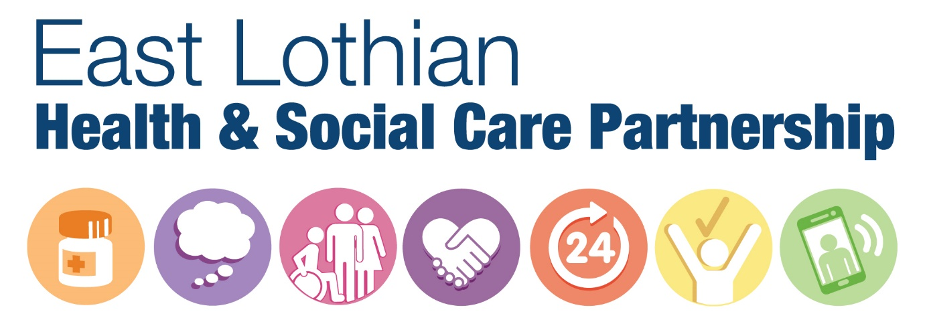
Big Conversation over Breakfast about the Strategic Plan

08.30 Registration and breakfast
09.00 Welcome – Peter Murray, IJB Chair
09:10 Achievements to date – review of our last three years – Alison Macdonald, Interim Director of Health and Social Care, ELHSCP
09:25 Time for questions
09.30 The development of the 2019-2022 Strategic Plan and a snapshot of engagement to date – Paul Currie, Programme Manager, ELHSCP
10:00 Workshop Session 1 – What’s important for you within the six priority areas of the Strategic Plan
11.15 Coffee, networking and comfort break
11:30 Workshop Session 2 – What are your views on the ‘Golden Threads’ commitments?
12:15 Feedback session with Alison Macdonald
12.30 Close
What happens to your feedback?
We will record your views and feed them into the final strategy.
Thank you for being involved.

