Draft East Lothian Dementia Strategy Summary Version

Contents
Why we need a dementia strategy 2
How we developed this strategy 2
What people told us they wanted 3
Taking a different approach 4
Our priorities 4
What we will do 4
Information 5
Diagnosis 5
Post Diagnostic Support 5
Support for carers 6
Expanding community connections 6
Maintaining independence 7
Care services and end-of-life care 7
Transport 8
Staff training 8
Housing 8
Valuing the contribution of people with dementia 9
Staying safe and understood 9

Why we need a dementia strategy

Dementia is an illness that causes damage to a person’s brain. It can lead to memory loss, problems with thinking and changes in behaviour. Dementia is not a normal part of ageing. There are different types of dementia but Alzheimer’s Disease is the most common.
Dementia mostly affects people over the age of 65 but can affect younger people too. Dementia can also affect both men and women.
People in East Lothian are living longer and this means the more people will live with dementia. We think that by 2040, almost 3531 people will be living with dementia in East Lothian. It will affect more women than men. Most of the people with dementia will be between 75-84 years old.
It can be overwhelming for people living with Dementia and for their carers and families. There is no cure for dementia but there is a lot that we can do to help people living with the illness and their carers. We want to make sure that we deliver high quality support when people need it.
The East Lothian Dementia Strategy is for people with dementia and their carers. It explains how health, social care and other groups will provide support and advice in East Lothian. This booklet sets out what they intend to do.

How we developed this strategy
We consulted with a lot of people to make sure that we got a wide range of views and ideas. We asked them what about would help supporting people with dementia and their carers. We talked to:
- people living with dementia
- their carers and families
- workers
- service providers.

We used a range of methods, including:
- storytelling sessions
- focus groups
- online meetings
- face-to-face meetings
- surveys.

What people told us they wanted
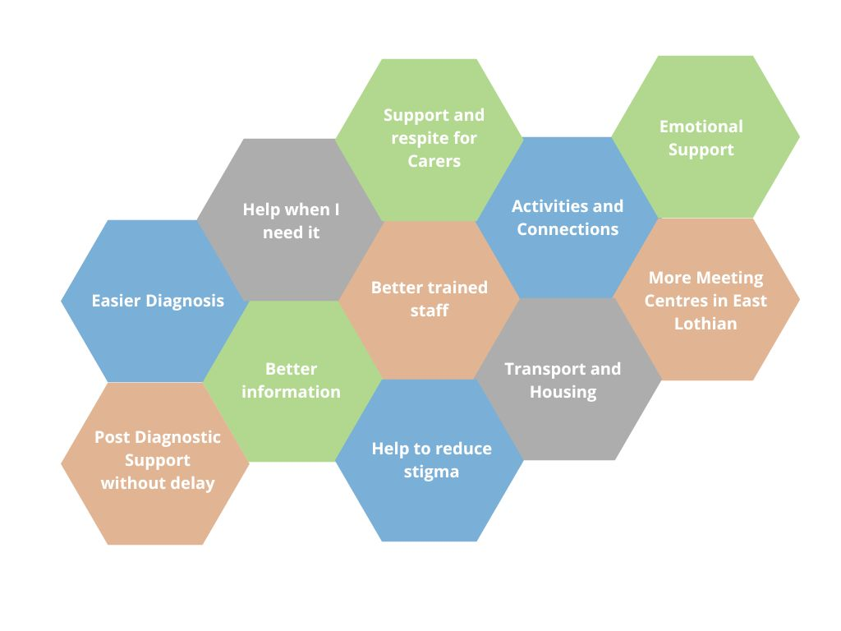

Taking a different approach
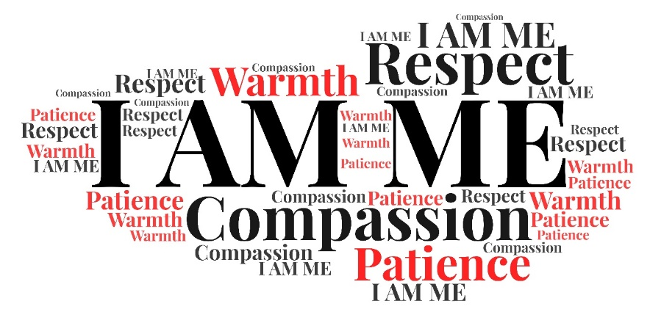
We wanted to help protect the human rights of people with dementia. This is the approach we took when writing this strategy. This will help to reduce stigma that people living with dementia experience. It will also values the contribution that people with dementia can make.
We know that people with dementia are citizens first.

Our priorities
We based our priorities on those of the Life Changes Trust. They worked with people with dementia and their carers to develop these priorities. They reflect what people with dementia have said are important to them.
- I get the help I need when I need it
- I am empowered to do things that are important to me
- I am able to be as independent as possible
- I live in a place that suits me and my needs
- I feel safe, listened to, valued and respected

What we will do
We will be making changes to help us to meet these priorities. The following pages give more detail.

Information
- We will provide better information at diagnosis and afterwards as people’s needs change. This will include information on services and on community activities and resources.

- We will make information accessible for everyone. We will offer information in a range of formats. This includes community languages, BSL, large print, audio and easy read.

- We will look at restarting the Memory Course for people with a new dementia diagnosis.

- We will develop a “Dementia Pack” for people with a new diagnosis of dementia. It will include information that people need about services and support.

Diagnosis
- We want to offer people the chance to get their diagnosis less clinical settings.

- We work with many third sector and community groups who support a wide range of people. We want to raise their awareness of the benefits of getting a diagnosis.

Post Diagnostic Support
- We want to review the Post Diagnostic Support service to see where we could improve it.

- We want to ensure people with dementia get support as soon as possible after diagnosis. We want to make sure that they know what that support should include.

- People with dementia get support for one year after their diagnosis at the moment. We want to extend that support so that people with dementia get support for the rest of their lives.
- We want to provide a single point of contact to ensure people can get help when they need it.

Support for carers
- We want to look at longer term options for breaks from caring. This includes looking at housing options for respite as well as care homes.

- We will look at developing companionship services.

- We will offer more day centre outreach programmes at evenings and weekends.

- We will develop more peer support. People with dementia will be able to meet to talk and share experiences and advice. We would also like to do this for carers.

- We will provide carers with advice and support on welfare benefits.

- Carers often experience grief when a loved one gets a diagnosis of dementia. We want to ensure carers can get emotional support for this.

- We will offer carers training to help them care for people with dementia.

Expanding community connections
- We will support the development of more Dementia Friendly East Lothian Friendship Groups.

- We will set up 5 more satellite Dementia Meeting Centres across East Lothian.

- This will include options for people in rural areas.

- We will promote the benefits of Dementia Friendly Communities. We will raise awareness of dementia in all areas of our work and with local community groups.
- We will work with local businesses to support them to be dementia friendly.

- We want to see how we can have more Alzheimer Scotland Dementia Café sessions.

- We will look at how best to develop a Musselburgh Day Centre.

- We will look at creating new community activities for people with dementia who are under the age of 65.

Maintaining independence
- We will promote the use of SMART Tec earlier to help people remain independent. SMART stands for Self-Monitoring, Analysis, and Reporting Technology. It helps people to manage things like turning lights and heating on at home. It can also alert services when people need help.

- We will look at how people can use Self Directed Support budgets can buy technology they need.

- We will make it easier to access physical aids, for example, to help with walking.

- Simple adaptations around the home can help people to stay independent. We will make sure that people know about this so that they can remain at home for longer.

- We will work with Enjoy Leisure to see how we can help people to improve their balance and core strength.

Care services and end-of-life care
- We will offer care-at-home support as early as we can to help you and your family to build routines that help you.

- We want to reduce the number of people going into hospital. We will offer people with dementia clinical treatment at home whenever we can.
- We want care homes to have good links with their local community, schools and nurseries. People in care homes will be able to continue to be part of their community if they want to.

- We will work with people with dementia and their families to plan ahead. Everyone should know what sort of end-of-life care the person with dementia wants. We call this 'anticipatory care planning'.

Transport
- We will ask the Royal Voluntary Service if they can expand their community driver scheme. We would like it to help take people to hospital. We would like them to make the scheme easier to use.

- We will ask the Transport Team at East Lothian Council to consider the needs of people with dementia. This includes improving bus services. We also want to see a bus stop at East Lothian Community Hospital.

Staff training
- We will make sure that all social care staff have the right training. This is very important for staff involved in care planning.

- We will provide 'stress and distress' training for staff. We will prioritise staff supporting people with advanced dementia. This includes hospital and care home staff. This will help care staff to better understand what it’s like to have a diagnosis of dementia. It will improve the way that they support people with dementia.

Housing
- When you get your diagnosis, we will make sure that you can talk about where you want to live. Information on housing options will be in a dementia-friendly format.

- We will offer council housing offers will dementia-awareness training.

- We will ask people building new housing to think about dementia-friendly design

Valuing the contribution of people with dementia
- We will help people with dementia to keep working if they want to. We can also help them to find opportunities as volunteers.

- We will encourage and support people with dementia belong to and lead decision-making groups.

- We will work with Dementia Friendly East Lothian to offer training for people with dementia. This training will help them in leadership roles.

- We will continue to engage with people with lived experience to help improve services locally.

Staying safe and understood
- We will publicise the benefits of the ‘Herbert Protocol’. This helps the Police to locate vulnerable people who are missing. We will also make sure our care homes are using this.

- We will make sure that people with dementia can get 'independent advocacy', if they need it. Independent advocates ensure that the views of someone with dementia are understood.

