The East Lothian Dementia Strategy – DRAFT

Purpose of the strategy

The purpose of the East Lothian Dementia Strategy is to set out a strategic plan to improve dementia services that encompasses all aspects of support from pre-diagnosis to end of life care. It will take a human rights based approach, ensuring that the rights of people with dementia and their carers remain at the heart of our policies and practice. It acknowledges that people with dementia have the right, regardless of diagnosis, to the same civil and legal rights as everyone else.

The impacts of a diagnosis of dementia are wide ranging, not only for the person with dementia but also on their families and carers. Dementia can result in a loss of a sense of identity, security and isolation. In addition to the cognitive changes, dementia also brings with it functional and sensory changes that affect how people with dementia are able to engage and manage in their own environment. The emotional toll for both the person with dementia and their carer is also significant due to the loss of relationships and connections and can result in depression, anxiety and stress. This is often compounded by the lack of awareness and stigmatisation of the illness within the general community.

Yet people with dementia have much to contribute. We have heard through our engagement of the lead roles people with dementia are undertaking, as well as inspiring stories of people with dementia becoming ‘dementia activists’, of those developing groups and activities, and undertaking peer support to help and advise others in a similar situation. We have also heard of the willingness of communities, businesses and local partners to improve and build on the supports already in place, and to create capacity where there is not. We have taken account of the voices of people with lived experience, and the feedback from our engagement form the basis of the actions laid out in this strategy.

There is much good practice already in place in East Lothian from embedding the principles of the Adults with Incapacity Act which ensures that interventions are to the benefit of the person with dementia, to good conversations taking place to determine the outcomes people with dementia want to achieve. East Lothian HSCP also has a real commitment to commissioning for personal outcomes and this is outlined in our new commissioning strategy.

Significant progress has also been made in developing community capacity and increasing awareness of dementia through the work being done by Dementia Friendly East Lothian, Alzheimer Scotland and other partners. There have also been excellent examples of partnership working between these community, third sector and formal HSCP services. We know that these social and community supports are a vital component in helping to maintain people with dementia at home for longer and to enable them to be active, healthy and engaged. While the integration of Health and Social Care services brings with it opportunities for innovation we must ensure to link these formal supports around these wider community networks to offer a holistic approach to supporting people with dementia and their carers, and to help change perceptions of their rights and abilities.

What is Dementia

Dementia is not a specific disease, but a group of symptoms that describes a deterioration in cognitive function beyond what might be expected as a usual consequence of aging. It results in an impaired ability to remember, think, or make decisions around everyday activities. It can affect memory, communication, reasoning and judgement as well as visual perception beyond typical age-related changes in vision and is often a progressive disease.

While there are various types of dementia, Alzheimer’s disease is the most common, accounting for around 50-75% of cases, with Vascular Dementia being the second most common. Those who experience the brain changes of multiple types of dementia at the same time have mixed dementia.

Although age is the strongest known risk factor for Dementia, it does not exclusively affect older people with early onset dementia (those affected under the age of 65) accounting for around 3.5% of cases of those diagnosed. Research has shown that a reduction in certain life-style risk factors may help prevent cognitive impairment which in turn may help reduce the risk of dementia. These include physical activity, obesity, poor diet, alcohol, diabetes, hearing loss and mid-life stress.

There is often a lack of awareness and understanding of dementia that results in stigmatisation, inequality and barriers to diagnosis and care. Although there is currently no cure for dementia, there are treatments, therapies and supports which can help people to maintain their skills and independence and support themselves and their carers to live well with dementia. There are also preventative measures and lifestyle changes that can be adopted at any age to help potentially delay or prevent the onset of dementia.

COVID 19

COVID-19 has had an unprecedented impact on health and social care services, and the people who use them. Research has shown that the most vulnerable groups, including those who have a diagnosis of dementia have been among the hardest hit during the pandemic. At the time, a diagnosis of dementia was not of itself listed as an increased risk factor for COVID-19, yet what we now know is of the deaths that occurred due to COVID-19 in Scotland 28% of those also had an underlying diagnosis of dementia.

The impact of COVID on residents in care homes, where many have a diagnosis of dementia, was well publicised. Bans on visiting caused significant distress to families and residents, and the use of PPE and masks meant many residents found it difficult to understand and communicate with staff causing greater levels of stress and distress.

Those with dementia in the community were increasingly isolated from the loss of normal routines and services that helped maintain their wellbeing. The closure of day services and loss, or restriction, of care at home services resulted in increased levels of cognitive decline and physical frailty while also negatively impacting mental health.

Unpaid carers who increased their caring role to supplement the loss of formal health and social care services, spoke of the toll on their physical, mental and emotional health. Balancing caring responsibilities in the context of the loss of their own support networks has left many carers at risk of burnout, stress and overwhelm.

Although restrictions have now lifted and many health and social care services have resumed, ongoing work is needed to continue to support those who have been affected and to support services to get back to pre-pandemic levels.

Dementia at a glance
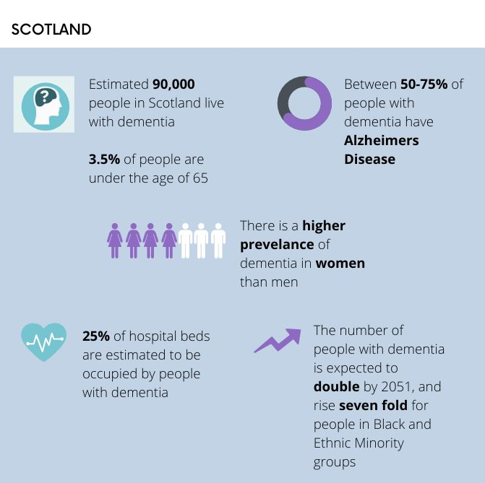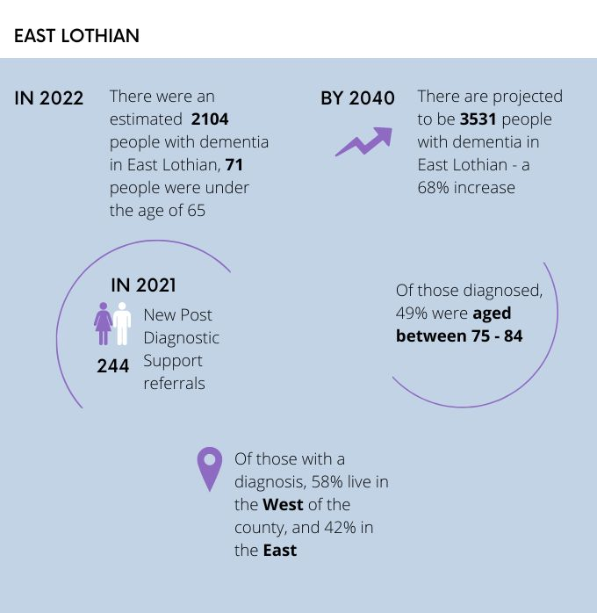

Development of the strategy and engagement

“The whole process needs to be evaluated in terms of how people are diagnosed and follow-up support timescales”

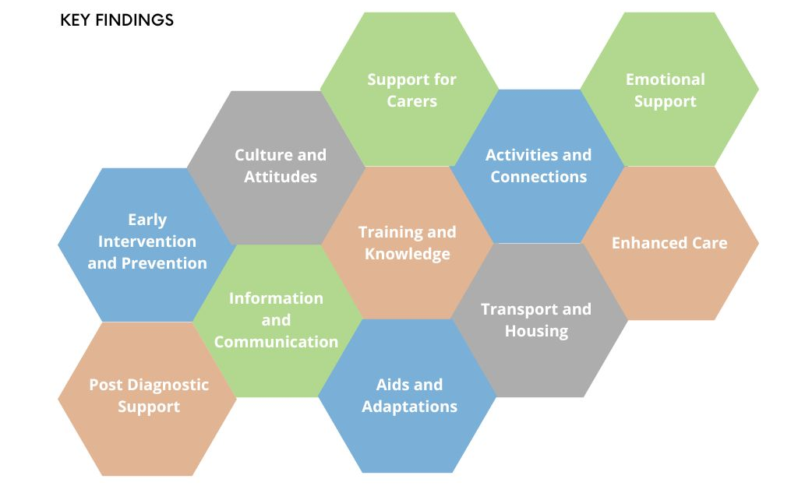
Engagement is the cornerstone of strategic planning and offers opportunities for people to participate in policy, service design and decision-making processes in order to deliver better and more responsive services that meet people’s preferences and priorities. It also offers greater understanding of where the opportunities are for co-production with partners and service providers.

There is a duty on public bodies to comply with human rights in everything that we do through both the Human Rights Act and the Scotland Act. Delivery of improvement to services must strive to uphold these rights.

In East Lothian much progress has been made with integration and embedding partnership working across our health and social care services. There is a significant amount of expertise across these services that has much to contribute to people with dementia and their carers. We aim to use this strategy to build on these strengths.

A range of communication and engagement events were held over the course of 2022, some in partnership with Outside the Box, who were commissioned to do community engagement on our behalf. Views were sought from people with lived experience and carers, the general public, service providers, community groups and health and social care staff. 660 people attended sessions where dementia was mentioned and 117 were involved in community engagement. We also included feedback from the Life Changes Trust event held for carers of people with dementia in 2018 where 26 carers attended.

We wish to thank all those who took part including those who attended face-to-face meetings, storytelling sessions and who completed online questionnaires. Analysis of national and local data has also informed the development of the strategy and has helped identify gaps, trends and areas of need. All the information collected has been considered and has helped to form the basis of the strategy.
The emerging themes and key findings have been valuable in helping East Lothian HSCP understand and confirm what was important to those living with dementia and their carers.
The clear message was that people with dementia and their carers want to remain as independent as possible for as long as possible, to enjoy daily life, activities and connections as we all do, and for their worth and value as individuals to be recognised and supported at each step of the dementia journey.
Earlier diagnosis away from clinical spaces, and access to post diagnostic support without delay were commonly mentioned. We were told how improvements in communication through joined up networks, community services and signposting would make it easier for people with dementia to access services and manage their condition, as well as avoiding having to repeat the same information to different staff across the HSCP. Training and awareness raising among HSCP staff and wider community partners would help provide improve understanding of the needs of people with dementia and reduce stigma.
People were impressed by new initiatives, particularly with reference to the Musselburgh Meeting Centre, but wanted further variety and flexibility in services. Carers voices were also heard, referring to the need for improved respite and breaks from caring as well as better information and access to aids and adaptations. Carers also told us of the importance of peer and emotional in supporting their own health and wellbeing.
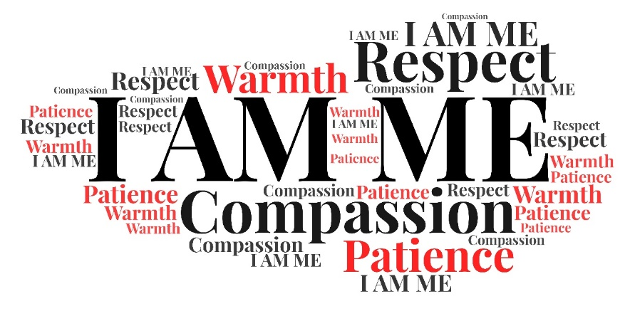

Our Approach

Human rights are basic rights and freedoms that protect us all and are based on dignity, fairness, equality and respect. The East Lothian Dementia Strategy will take a human rights based approach to the provision of our dementia services by embedding the rights outlined in the Charter of Rights for People with Dementia and their Carers in Scotland. The aim is to recognise that people with dementia are citizens first and the framework of support surrounding them should operate with this at its core.
Acknowledgements to: DFEL Musselburgh Friendship Group, Lorna Hill, Sharing a Story CIC, Fringe by the Sea and Year of Storytelling for the use of the graphic
The strategy will also use the five main outcomes outlined by the Life Changes Trust which were developed based on contributions from over 100 dementia projects and what their beneficiaries said was most important to them. Each area is interdependent and taken together these priorities contribute to a person-centred, whole life approach.

Our partners

In order to meet the outcomes and actions listed within this strategy, we will continue to engage with a broad range of health, social care, housing, third sector and community services, and in particular key dementia services such as Dementia Friendly East Lothian (DFEL) and Alzheimer Scotland. East Lothian HSCP is also developing a range of other strategies and action plans including planning for Carers, Mental Health, Sensory Impairment, Suicide Prevention, Physical Disabilities, Learning Disabilities, Palliative Care and Primary Care.
There will be common themes among many of these and interlinking goals. Each strategy will consider the needs of people with dementia and their carers within their own right and outline any specialist support required.

Outcome 1: I get the help I need when I need it

The East Lothian Pathway
Dementia has a number of stages as it progresses, requiring access to different services at different times. Although the pathway below has been developed to outline the range of the services available locally for both people with dementia and their carers, it is not intended to be proscriptive. We recognise that everyone’s journey through dementia is unique. People may wish to access services at times other than those suggested and as their individual circumstances require.

People with dementia and their carers have the right to the highest attainable standard of physical and mental health, as well as appropriate levels of care to offer rehabilitation and encouragement. We aim to ensure that everyone with dementia has access to these services to offer them the help they need, when they need it.

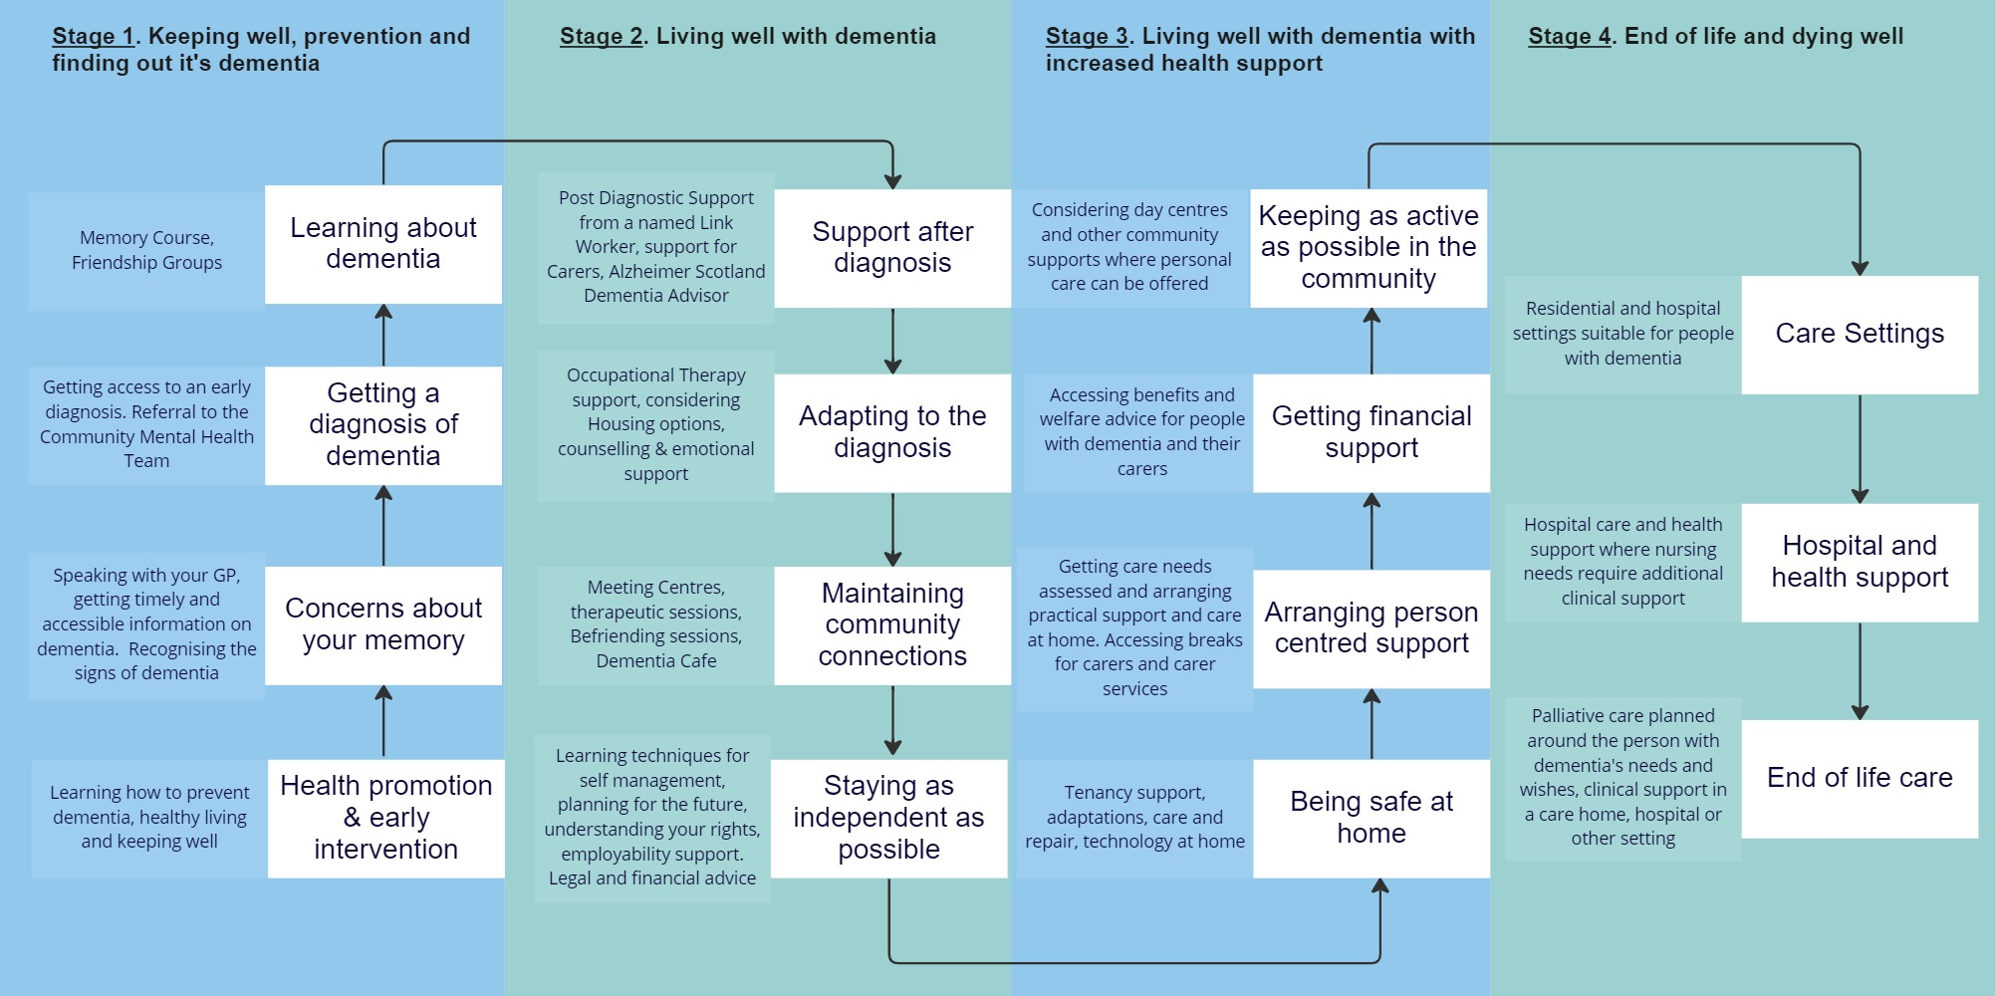

Finding Information
“When you don’t know, you don’t know where to start – we’re fumbling in the dark!”
“There is currently the risk of a gap between initial diagnosis and support – very scary for people – whereas with a cancer diagnosis you get a big pack, with dementia you get hardly anything initially”
“It’d be great to have a comprehensive guide to help you through”
People with dementia and their carers have the right to accessible information in order to participate in the decisions that affect them. Knowing where to turn to at each stage and how to access the various supports on offer requires comprehensive information to be available to allow people to manage their own health and wellbeing, and to live well with dementia in a way that best suits their circumstances. Requirements for information will change at key transition points as dementia progresses.
Any information developed must be in an accessible format, bearing in mind that it is common for people with dementia to experience sensory changes as part of their condition.
What we will do
- Review the information provided at point of diagnosis to support people with dementia and their carers to learn more about their condition and develop a “dementia pack” jointly with the Older People’s Mental Health consultant, the Alzheimer Scotland dementia link workers and other partners.
- Ensure information is accessible to all including British Sign Language users, minority ethnic groups and young carers who may be caring for a relative with dementia. This includes exploring options via our equalities team to ensure appropriate access to translation services, including those specialising in medical translation.
- Explore opportunities to provide information on preventing or delaying dementia. For those with Mild Cognitive Impairment or a diagnosis of dementia, this will include linking in with national health messaging as well as local initiatives such as access to Alzheimer Scotland brain health survey and use of local resources such as the Meeting Centre. In schools where there is a risk of low educational attainment this should include publicising the Alzheimer Scotland My Amazing Brain programmes to raise awareness of brain health.
- Review and restart the Memory Course for those newly diagnosed with dementia
- Explore how mental health support can be built into the diagnostic pathway to support people to adjust to their diagnosis
- Develop a supplementary guide with the Alzheimer Scotland link workers and other partners detailing wider community support and services at each stage of the dementia journey

Timely Diagnosis
“I started to notice things weren’t right with him about 3 years ago…and we are still waiting for a diagnosis”

A timely diagnosis has obvious benefits and is the gateway to receiving quality post-diagnostic support, medication to delay symptoms, as well as information to understand the condition. Diagnostic data shows a new trend in people being referred early with Mild Cognitive Impairment, providing an opportunity to offer health prevention advice to delay symptoms.

There is an increased prevalence of dementia in those with a Learning Disability (LD), particularly among people with Down Syndrome. Although baseline assessments are completed proactively after the age of 35 in those with Down Syndrome, there remains a significant portion of people with an LD diagnosis not known to the Community Learning Disability Team (CLDT).

What we will do:
- Explore ways to increase available options to obtain a diagnosis of dementia to enable people to have choice as to where this is completed and to enable support to be offered as soon as possible. Options may include diagnosis via community based models, via psychiatrist at the Memory Clinic, or by GP’s. Where diagnosis is completed via GP’s or psychiatry, a common understanding/checklist should be developed of routes of support available across the community for people with dementia to be referred to.
- Increase awareness of the benefits of a diagnosis, involving community partners, third sector organisations and statutory services in promoting this
- Consider how we provide, from the available resource, a wider pathway for all people diagnosed with a learning disability to receive an annual health check regardless of whether they are already known to the CLDT service
- Improve data collection on numbers of people diagnosed with dementia and those accessing formal HSCP support to inform future service development. Data on gathering information on ethnicity and diagnosis of type of dementia should also be improved.

Post diagnostic support
“People get a diagnosis and then they are ’on hold’”
“By that point his dementia had advanced and we needed other supports, but we were past the year and got signed off – case closed”
“It would make such a difference if someone could say – if you need anything, just phone and this is the number!”

Quality post diagnostic support helps people to adjust to their diagnosis, both practically and emotionally, providing people with dementia and their carers with the tools and resources they need to live as well and as independently as possible. It also supports people with dementia’s right to advanced decision making. In East Lothian, post diagnostic support is delivered over a one year period by a named Alzheimer Scotland Link Worker using their 5 Pillar Model.

What we will do:
- Review the Post Diagnostic Support service using Health Improvement Scotland’s Quality Improvement Framework to identify where areas of practice could improve.
- Work with our partners to determine the most effective way to integrate the Alzheimer Scotland 8 pillar model to enable each person to receive this for the duration of their time with dementia. Partners will include DFEL, Alzheimer Scotland, Older Adults Mental Health team and others. The review should embed a single point of contact and self-referral into the service. The review should also explore how best to link in local carer services.
- Evaluate the Post Diagnostic Support provided within CLDT to review whether a more formal pathway is required
- Incorporate information on risk factors into post diagnostic support that can help to delay symptoms of progression

Care at home
Many carers reported they were not being supported until they reached crisis point although they try to raise issues as they arise. Earlier intervention would help people with dementia build routines that could help them self-manage for longer and would do much to alleviate carer stress.

What we will do:
- Support the development of a new approach to commissioning care at home services through the new Care at Home Change Board
- Implement the outputs from the work completed with IRISS (Institute for Research and Innovation in Social Services) to re-imagine our approach to Social Work services for adults in East Lothian and how best to implement a more outcome focused and early intervention approach.

Hospital Care and Preventing Admission
“Despite my husband having fairly advanced dementia, we had to wait in A & E for 6 hours, he became distressed and had to get a commode…but I was given no assistance or wipes”

There is recognition that hospital admission can have a significant adverse effect for people with dementia. Improving the availability of local hospital services and day clinics at East Lothian Community Hospital and working to prevent admission through the use of intermediate care services will help people with dementia avoid the stress of having to access hospital services out of area.

What we will do:
- Develop good practice on general ELCH wards by rolling out a programme of training to nursing staff to increase knowledge of strategies for managing stress and distress, support development of dedicated care plans, and prevent inappropriate admissions to Oaktrees.
- Ensuring staff within Oaktrees receive more specialist training to enable people with dementia to be assessed locally resulting in fewer transfers of patients to Edinburgh hospitals

Residential and Enhanced Care
The majority of residents in care homes have a diagnosis of dementia. Increasing the current offer of clinical support and specialist training to care home managers and staff will increase understanding and management of complex behaviour and improve outcomes for care home residents.

What we will do:
- Expand the NHS Care Home Team to ensure that all of East Lothian’s care homes can receive clinical and education support
- Offer face-to-face stress and distress training to care home staff via the East Lothian Care Home Assessment, Support and Education team (ELCHASE) or the Dementia Specialist Improvement Lead to improve management and understanding of complex behaviour.
- Explore re-establishing OT support within ELCHASE to increase access to wider therapies to support stress and distress behaviour
- Explore development of an enhanced care unit to support those with complex behavioural and neuropsychiatric symptoms.
- Support care homes to provide intergenerational support and awareness raising in the local community to assist them in maintaining community connections

Palliative Care
Timely access to good palliative and end of life care is a national priority and a new Palliative Care Strategy is under development. As improvements in health care are reducing rates of death from other diseases, more people are reaching the advanced stage of dementia. Planning for end of life care is currently embedded in our local care homes through the use of anticipatory care planning, supporting people with dementia’s right to advanced decision making.

What we will do:
- Build in reviews of anticipatory care plans within the enhanced post diagnostic support service given that people with dementia’s needs and wishes may change over time.

Support for Carers
“Being continually stressed and in a vulnerable state eats away at your ability to speak up”
“You end up with no ‘head space’ and even the most articulate of people can be reduced to a mess when you are caring for someone 24/7”

Caring for someone can be rewarding, however coping day to day with meeting the needs of a loved one is often challenging and exhausting. The Partnership is currently reviewing the East Lothian Carers Strategy to ensure it remains fit for purpose following COVID, and to ensure carers continue to access the support they need. There are currently significant gaps in access to replacement care to provide carers with a break and East Lothian HSCP is aware of the need to address this.
There are significant crossovers between the dementia and carer’s strategies and there will be a need for ongoing links between the two workstreams to ensure that we take into account the specific needs of carers of people with dementia.
What we will do:
- Explore longer term options to provision of respite services as well as increase the number of respite beds available locally
- Develop local training options for carers to support them to understand and manage the condition including managing stress and distress behaviour
- Continue links with the East Lothian Carers Strategy including the review and simplification of Adult Carer Support Plans
- Develop an increased range of dedicated carer peer support for those caring for someone with dementia
- Ensure Carers of East Lothian’s counselling service supports those experiencing anticipatory grief
- Improve the data being gathered around young carers supporting people with a diagnosis of dementia

Outcome 2: I am empowered to do the things that are important to me

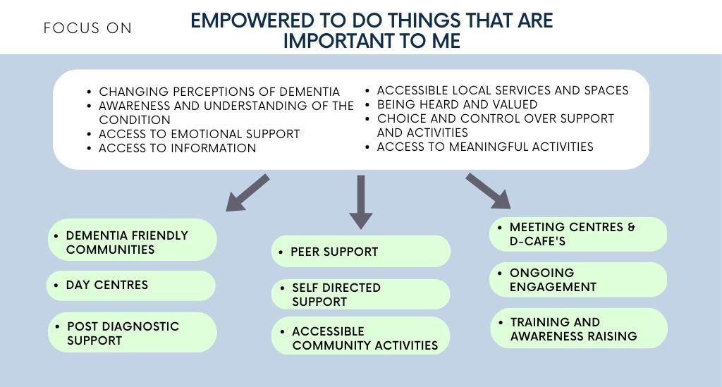
Maintaining community connections
People with dementia and their carers have the right to the same recreational, leisure and cultural life in their community that we all do. By far the greatest number of responses received over the course of our engagement was in relation to the desire to access good local connections and activities.

We know the benefits of reducing social isolation. Research also shows that if people make good emotional, social and practical adjustment to dementia early then it is likely they will experience fewer distressing symptoms later and will be able to live at home for longer with a better quality of life. Our aim is to increase the offer and range of community activities across all stages of the dementia pathway to enable people with dementia to remain active, engaged and healthy in older life while also supporting carers to receive a break from caring.

Dementia friendly communities and peer support
“You don’t realise how much lack of understanding there is in the community, until you are affected or have a diagnosis”
“We made contact with Alzheimer Scotland and came to the peer support groups. We’ve found out more information here than from anywhere else and it’s good to meet people who can share some of their experiences”
“Although our journeys on this road may be different, we all understand and just ‘get it’. We understand that sometimes we just need someone to be there, not to fix anything…but just to let us feel that WE (carers) are also cared for and supported”

Dementia Friendly East Lothian (DFEL) has been vital in supporting the development of East Lothian’s 8 dementia friendly communities, working with a range of local organisations and groups to promote the empowerment of people with dementia and striving for local changes to make services accessible.

Such initiatives help support a shift in culture and attitudes and reduce the stigma around dementia. They also help support the rights of people with dementia including their right to maintain maximum independence, full inclusion and participation in all aspects of life, the right to respect and to full access to recreational, leisure and cultural life in their community.

DFEL has also developed a range of local peer support through the Friendship Group model and the Open Arms Carers Group offering chances to build relationships, have fun, address social inclusion and provide information on key links to services. East Lothian HSCP will continue to work in partnership with DFEL and other partners to increase the offer of peer support.

What we will do:
- Work with DFEL to support the roll out of the Friendship Groups to increase access to peer support including increasing access to dedicated peer support for carers of people living with dementia
- Ensure that dementia hubs/groups are accessible to those with a sensory impairment or for people who are deaf with dementia.
- Ensure that peer support groups are included in the “dementia pack” for those newly diagnosed
- Explore options for the Friendship Groups to be included in co-producing the Memory Course in partnership with other organisations for people newly diagnosed
- Promote the value of developing Dementia Friendly Communities across all HSCP action plans, working across arts, culture, leisure and recreation; businesses and shops; children, young people and students; community, voluntary, faith groups and organisations as well as transport

Wider community support/services
“Part of the problem is that dementia is a hidden disease which can cause more barriers and stigma – if you look at people with dementia you’d think there was nothing wrong”
“I try to hide it – it keeps the brain going”

Increasing access to local community spaces and services through making environmental changes such as improved signage, hearing and visual modifications will support people with dementia’s ability to engage with their local community. Wider access to community activities is especially important for those people who prefer not to join in local groups and people with young onset dementia.

Working with local communities and services in a more collaborative and supportive way to build on community led solutions and existing capacity will help offer people with dementia greater options to access supports that matter to them, and at the same time do much to combat stigma surrounding the condition. Local services such as libraries are often a first port of call for information in finding out what services are available and pathways to support.

What we will do:
- Raise awareness of the benefits of good design elements within local council buildings in improving access for people with dementia such as that modelled by the Fraser Centre
- Develop a community engagement strategy to offer awareness raising sessions across key community groups and services.
- Work with Local Area Partnerships and Health and Wellbeing groups to keep the needs of people with dementia on their local agenda.
- Work with local libraries to collate and offer quality information on local community services for people with dementia and their carers
- Work with education and local youth groups to increase the range of intergenerational activities including such initiatives as “digital buddies” and Dunbar Diners
- Work with local businesses to improve community understanding with stickers provided to recognise they are a dementia-friendly space.

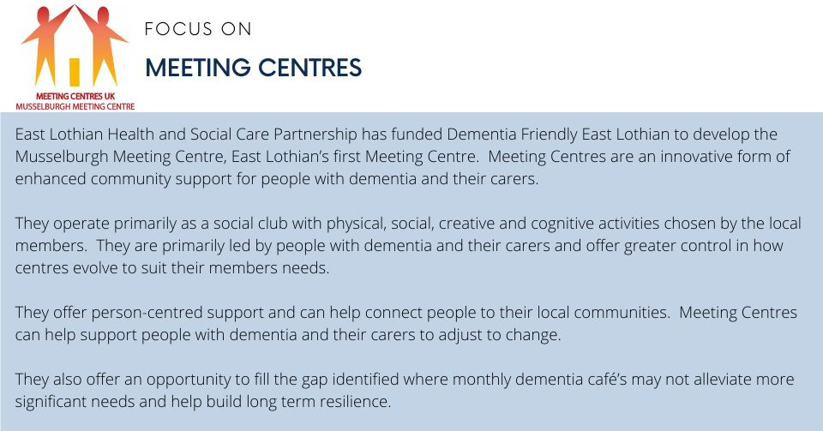
Dementia Café’s and Meeting Centres
Groups such as Alzheimer Scotland’s Dementia Café’s and Meeting Centres offer many benefits for those with low to moderate levels of dementia including:

- the opportunity to engage with others in a similar situation in a safe, inclusive environment where people can develop social networks and access peer support
- the ability to share experiences and emotional responses to dementia while engaging in social activities tailored to their capacity and interests
- signposting and information on wider groups and activities available locally.
- opportunities to learn more about dementia, self-management tips and practical help
- access to specialist information from key professionals
- spaces where carers can attend in conjunction with the person they care for, providing access to respite or support for themselves

People told us that access to activities has been fragmented. Although Alzheimer Scotland Dementia Café’s now run in 3 locations in East Lothian and people spoke highly of the groups, they would like these to take place more frequently than once a month.

A large portion of East Lothian is rural with a higher portion of people over the age of 70 living in rural areas. There is a need to ensure that access to Meeting Centres is available in rural communities.

What we will do:
- Further expand the Meeting Centre model across the county to include an additional five satellite sites
- Explore the use of the Powys hybrid/pop up model for Meeting Centres in more rural areas
- Build and support partnership working and learning by working together with carers, people with dementia, third sector and social enterprises to make the Meeting Centre and any new satellites sustainable in the long term via a Public Social Partnership
- Explore options to increase the frequency of the Alzheimer Scotland D-café’s
- Explore the use of the Musselburgh Meeting Centre as an information and community hub including signposting of those to the centre when newly diagnosed to improve understanding and self-management.
- Explore options to undertake joint commissioning with a neighbouring authority to develop peer support groups for people with young onset dementia where numbers are low

Older People’s Day centres
“Make sure that, in all your caring duties, you find time for yourself”

Day centres are a valuable resource for people with more advanced dementia and mobility problems, offering companionship, stimulation and support. They also offer carers a chance to take time for themselves away from caring responsibilities. Day centres provide a person-centred, outcome focused approach through high quality of care and support provided. At least 60% of all day centres users have a diagnosis of dementia and in some centres it is over 90%.

All centres offer a blended model of centre based and outreach community support for older adults with complex needs and their carers to provide options for people to receive 1:1 support in the community and access activities of their choice in a more flexible manner.

What we will do:
- Continue to fund the nine existing local day services in East Lothian
- Review use of the outreach programme, including options to expand this to include evening and weekend support.
- Fund the development of a Musselburgh Day Service where there is currently a gap in provision and where a high number of people have been identified as living in the community with dementia.
- Explore the use of the Alzheimer Scotland dementia specific day centre model for Musselburgh which offers dementia specific therapeutic activities, life story work, and activities tailored to the needs of their attendees to promote independence and engagement.

Outcome 3: I am able to be as independent as possible
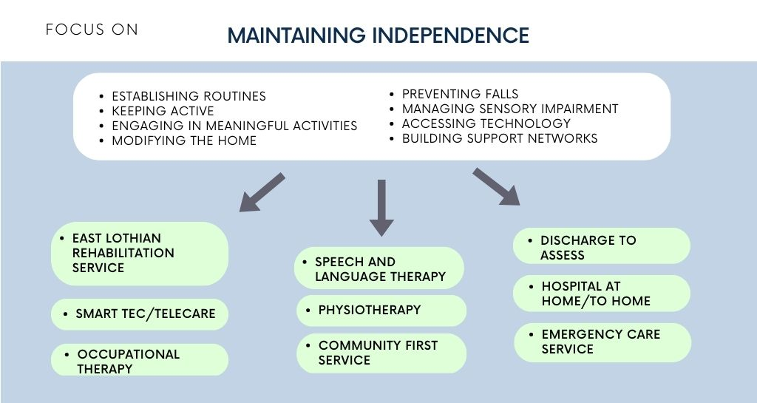

Promoting and Maintaining Independence
People with dementia and their carers have the right to maintain maximum independence, social and vocational ability, and full inclusion and participation in all aspects of life. Support to maximise independence relies on a variety of factors.

Allied Health Professional (AHP) such as Occupational Therapists, Physiotherapists, Dieticians and Speech and Language Therapists, and SMART Tec/Telecare technicians offer expertise to help people with dementia to live well throughout all stages of the condition, improve hospital and discharge outcomes, and enable people to remain safely and confidently in their own homes and communities for as long as possible.

They can be a point of early detection for functional changes such as difficulties performing everyday tasks, problems with mobility, balance and muscle weakness. They can support signposting for early diagnosis as well as creating strategies to increase or maintain functional performance to help people remain as independent as possible. Offering support both in hospital and community settings, they can support people after a fall to regain confidence, suggest environmental changes or adaptations to prevent future falls, and support people to return home.

Our Digital platform Access to a Better Life in East Lothian offers advice, resources and external links to support self management. It also enables people to find out how well they are managing with daily living activities using the Life Curve and offers suggestions for improving independence.

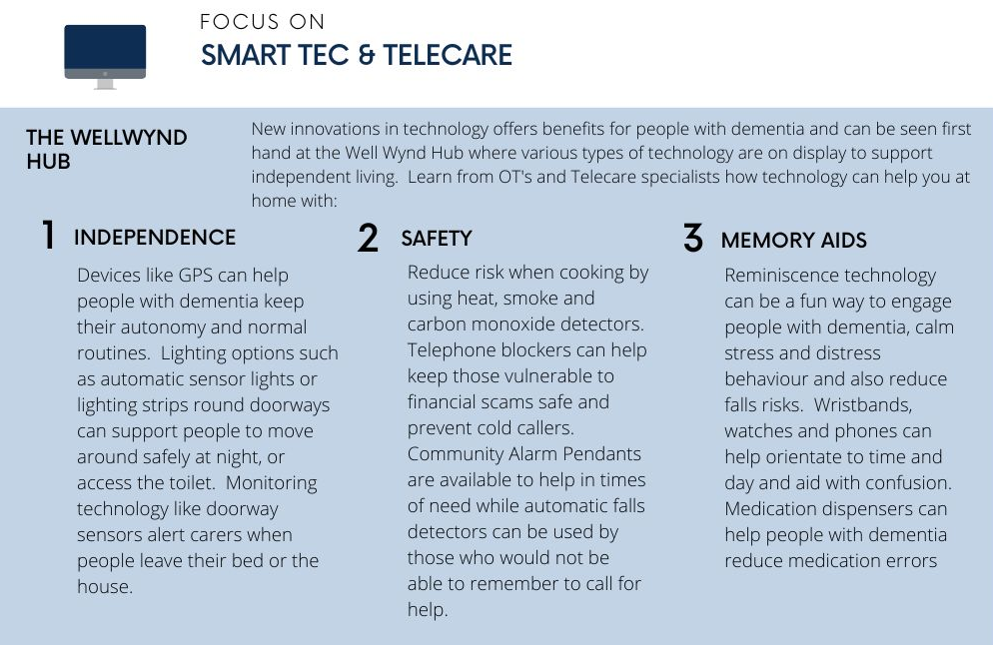
What we will do:
- Work with enjoy leisure to offer classes in to improve balance and core issues.
- Expand access to Active and Independent Living Clinics and Smart Tec Clinics across the county, such as that currently offered via the Well Wynd Hub.
- Develop a dedicated AHP strategy
- Ensure the East Lothian Rehabilitation Service is linked into the Post Diagnostic Support pathway
- Promote the use of the Access to a Better Life in East Lothian digital platform and virtual smart house to those newly diagnosed, as well as to care home managers to support environmental changes in care homes
- Promote the use of SMART Tec and Telecare earlier in the dementia pathway to ensure people get the full benefit of technology to maintain independence
- Expand SMART Tec education sessions to local care homes where stress and distress behaviour and falls are more common
- Increase awareness in the community to combat the belief that people with dementia are unable to use technology
- Increase education sessions among HSCP staff to ensure that technology becomes part of their toolkit
- Explore options to use SDS and carer budgets to purchase technology

Community First Service
The Community First Service run by Volunteer Centre East Lothian (VCEL) provides support to people over 50 to access community based services to:

1) Support people to achieve their vision of a good life, use their personal strengths and make a contribution to their community
2) Help communities to be self-supporting
3) Help to transform systems, building bridges and strengthening relationships between citizens, communities and services,
4) Support hospital discharge and prevent readmission.

What we will do:
- Explore expanding the offer to include companionship services to enable carers to have a break

Screening for Sensory Impairment
There is growing evidence of a link between sensory impairment and dementia including that hearing impairment increases the risk of cognitive decline.

What we will do:
- Provide information at key points for people to understand the likelihood of increased sensory impairment with dementia and risk to cognitive decline
- Publicise pathways for referrals to audiology in particular to care homes where there are high rates of people with hearing difficulties
- Improve information gathered on vision and hearing loss by social care staff and care home staff prior to admission to a care home
- Work with care home managers to implement simple screening for new residents for impacted wax which can cause pain and hearing loss
- Highlight the benefits of adapting the care home environment for people with sensory impairment including measures such as providing quiet areas for those with hearing difficulties, and appropriate lighting for those with vision loss
- Raise awareness among care home staff of the impact of sensory impairment and the link to Neuropsychiatric symptoms
- Work with care home managers to highlight the importance of regular maintenance of hearing aids and glasses as simple assistive devices.
- Take account of recommendations in the new Scottish Government See/Hear Strategy due 2024.

Meaningful activities and employability support
“I’m very worried about losing my livelihood and what people might say when I have to tell them”

People with dementia have the right to employment and a diagnosis of dementia does not automatically mean a person has to leave work. In addition to the obvious financial benefits, there are other mental and physical health in continuing employment, including the social connections it brings. The Equality Act 2010 obliges employers to provide reasonable work adjustments for people with a disability. Reducing the stigma attached to dementia is an important step in enabling individuals to acknowledge and discuss any problems that they might be having at work because of dementia.

What we will do:
- Raise awareness of the needs of people with dementia within our Local Employability Partnership and Disability and Health subgroup including incorporating this into our local employment strategy
- Work with local volunteering services such as VCEL to support people with dementia to access volunteer opportunities
- Link in employability services to local community groups such as the Meeting Centre, Friendship Groups and peer support groups to raise awareness of available support

Outcome 4: I live in a place that suits me and my needs

Housing
People with dementia have the right to live in dignity and security. The quality of life of someone living with dementia is affected by where and how they live. For many people home is a place of safety, connectedness with neighbours, friends and family, and where their surroundings contributes to a sense of self and identity. We know that people with memory loss also function best in a familiar environment.

What we will do:
- Ensure discussions on housing options are embedded into post diagnostic support and that information on options and tenancy advice is provided in a dementia friendly format.
- Promote the importance of dementia awareness training for housing officers and tenancy support officers, particularly in cases where people with dementia may struggle to maintain tenancies
- Provide advice to Housing to ensure new developments including specialist housing take into account elements of dementia friendly design such as the use of the Kings fund Tool
- Review information provided for those entering sheltered housing and retirement housing and revise into a dementia friendly format

Importance of adaptations
Most people live in mainstream housing, with two thirds in the owner-occupied sector where the vast majority of homes lack even basic accessibility features. Aids, adaptations and assistive technology help people with dementia to live better in all forms of housing and should be considered before making a decision to move home. Aids can also support carers to continue in their role with less risk to their own physical health.

What we will do:
- Provide information on the benefits of simple adaptations including improved lighting, improved signage such as in sheltered housing, changes to colour schemes and consideration of design and layout to support people’s ability to remain independent at home.
- Publicise the use of the Access to a Better Life platform to improve awareness and access to physical aids
- Explore the development of step up/step down facilities locally where those being discharged from hospital, or at risk of being admitted, could be appropriately assessed to determine people’s abilities and strengths in a homely environment.
- Highlight access to care and repair during post diagnostic support which offers assistance to home owners and private tenant’s over 60 to support with help and advice in carrying out repairs, maintenance and adaptations.

Transport
“The Parking around local services is often not accessible, meaning we have to negotiate walking a distance with someone who needs a lot of physical support at times”

Public transport can be a lifeline for people with dementia who are no longer able to drive although can present issues such as recognising places, managing money and difficulties with access. Ensuring local transport facilities are aware of how best to support people with dementia is key to maintaining independence and keeping close links with their community.

What we will do:
- Review the existing RVS service to develop a broader community transport offer including the offer of enhanced support at hospital if travelling alone and simplify processes for referral to the GP Transport scheme
- Work with Transport colleagues to highlight the needs of people with dementia including the benefits of dementia awareness training
- Work with Transport to review the current service provision including the option of a bus stop outside East Lothian Community Hospital to improve access

Financial support
“The sheer volume of what you have to think about means that you often just don’t have the headspace to sit and write forms for what you need”

People with dementia and their carers have the right to the same economic rights as we all do, including an adequate standard of living. Having a diagnosis of dementia can place a significant financial burden on families and one that can extend over a significant period of time. For those with young onset dementia the financial impact may be greater due to earlier loss of employment income and reduced pension entitlements or other ongoing commitments such as child care costs.

What we will do:
- Publicise support available from third sector organisations such as VCEL in providing support to complete benefit forms
- Ensure that carers of people with dementia are aware of the income maximisation support available from Carers of East Lothian’s welfare rights
- Ensure that all people diagnosed with dementia are referred for income maximisation

Outcome 5: I feel safe, listened to, valued and respected
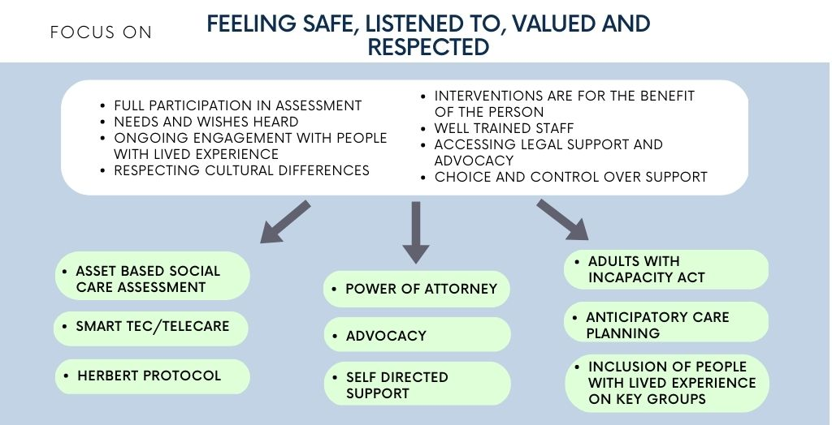

Including the voice of people with lived experience
People with dementia not only have the right to have their voices heard and to participate in the formulation and implementation of policies and services that affect their wellbeing, but have much to contribute in leading improvement of services. Enabling people with dementia to participate in key roles will also assist in reducing the stigma around a diagnosis.

What we will do:
- Actively promote people with dementia in lead roles in groups such as the Musselburgh Meeting Centre
- Work with DFEL to promote the role of the Meeting Centre as means of accessing training and mentoring in leadership, advocacy and peer to peer skills to build confidence and capacity
- Ensure people with lived experience of dementia are included in key groups such as the Partnership’s Change Boards to enable their experience to be incorporated into strategies and policies that affect them
- Continue engagement with people with lived experience of dementia to identify gaps in local community resources and support development and on service change and improvement

Respecting individual circumstances
People with dementia have the right to respect for their individual circumstances including the right to be free from discrimination based on grounds such as age, disability, gender, race, sexual orientation or religious beliefs. Reducing health inequalities, combating stigma associated with dementia, and embedding a human rights approach to services will help reduce discrimination. This reflects the ethical challenges in the support and protection of people living with dementia, and legislation alone will not be sufficient to ensure the protection of their rights.
What we will do:
- Support awareness-raising campaigns to include education on human rights. Campaigns should also highlight dilemmas related to ethical issues which arise when providing dementia care.
- Ensure that we gather equalities data and understand prevalence rates of those with protected characteristics, including women and black and minority ethnic communities
- Work with LGBT Health and Wellbeing on increasing awareness of the additional challenges faced by LGBTQ+ groups.
- Work with organisations representing Black and Minority Ethnic people on increasing awareness of the additional challenges faced

Access to Advocacy and legal services
People with dementia have the right to access social and legal services to enhance their autonomy, protection and care. As the risk of vulnerability increases as dementia progresses, it is vital that people with dementia and carers have access to independent support to represent their own views where they have difficulty expressing their views, or are unable to do this themselves.
What we will do:
- Complete a review of the current advocacy services to ensure services remain able to meet demand as numbers of people with dementia rise
- Ensure that advocacy services are available for people with young onset dementia
- Promote the uptake of power of attorney within the post diagnostic support pathway
- Ensure people with dementia know their rights and how they can get help to make sure they are upheld
- Work with Advocacy services to respond to the experiences of people who feel their rights were not upheld

A knowledgeable and skilled workforce
People with dementia and their carers have the right to services provided by staff who have had appropriate training. Upskilling health and social care staff with appropriate knowledge and understanding about dementia, including the wider sensory and functional impacts of the condition, will ensure that people with dementia and their carers are able to receive person-centred, holistic support and are treated with respect and dignity. We aim to have a more structured approach to dementia training for wider social care staff, as well as those in the third sector and wider community partners who offer signposting and support.

What we will do:
- Make completion of the NHS Education for Scotland Promoting Excellence Framework models at Informed level mandatory for those all social care staff and incorporate this into the workforce training plan
- Make Skilled level mandatory for those involved in care planning to improve the quality of support by staff who have direct contact with people with dementia
- Explore options for awareness raising training to be made available for wider housing, community and third sector partners through initiatives such as Alzheimer Scotland’s ‘Dementia Friends’ sessions or use of the Meeting Centre for training.

Full participation in assessment
People with dementia and their carers have the right to full participation in their care needs assessment and in planning, deciding and arranging their support. Building on the good conversations already taking place and shifting to an asset based approach that focuses on building on existing strengths and abilities will help ensure that assessments are structured around outcomes that are important to people with dementia and their carers.

What we will do:
- Review the current assessment format in Adult Social Work to shift to an asset based approach and a personal outcome focus to better incorporate people’s abilities and strengths
- Improve information provided on Self-Directed Support including providing examples on ways this can be used flexibly.
- Support Volunteer Centre East Lothian, our Third Sector Interface, to develop and embed approaches to personal outcomes across the third sector.

Herbert Protocol
The Herbert Protocol is a scheme to support the Police and other agencies to locate a missing person with dementia quickly and safely. Increasing awareness of the scheme will help keep people with dementia as independent and as safe as possible.

What we will do:
- Ensure the Herbert Protocol is in use in all East Lothian care homes
- Ensure it is translated into relevant community languages and made accessible to all communities
- Embed information on the benefits of the protocol within post diagnostic support

Appendix A

Policy Context – Relevant policy, drivers and legislation

National Policy
A number of key strategies, policies and legislation have been published over recent years that include aims and measures to support people with dementia and their carers. These include:

- Scotland’s National Dementia Strategy (2017 – 2020). The third of Scotland’s Dementia strategies aims to build on the existing work that has taken place around improving the quality of support for people with dementia and their carers. It outlines key outcomes that it wishes to achieve including:

  - People with dementia have better control over their own care planning
  - Earlier access to quality, person-centred post diagnostic support
  - People with dementia are supported to live at home/in a homely setting as long as they wish
  - Timely access to good palliative and end of life care
  - Better recognition and involvement for carers through all parts of the care journey
  - The right to access good quality, dignified and safe treatment through all care settings
  - More dementia friendly and dementia enabled communities

- The Carers (Scotland) Act 2016. Introduces new rights for unpaid carers and new duties for local councils and the NHS to provide support to carers including the duty to offer carers their own support plans, include carers in all hospital discharges and to prepare a local carers strategy

- Public Bodies (Joint Working) (Scotland) Act 2014. Sets out the framework for integrating adult health and social care services to ensure consistent provision of quality and sustainable services in order to meet increasing demand.

- Social Care (Self Directed Support) (Scotland) Act 2013. Ensures that people have more choice and control of how their services are delivered and the level at which they wish to be involved in managing their own support.

- The Standards of Care for Dementia in Scotland (2011). Outlines the range of rights that people with dementia and their carers are entitled to as well as providing guidance to health and social care staff and providers in their care of people with dementia. The Standards are underpinned by the Charter of Rights for People with Dementia and their Carers in Scotland.

- Adults with Incapacity (Scotland) Act 2000. Provides a framework for safeguarding the welfare and interests of people who lack capacity to make some or all decisions for themselves. It enables carers and others to have legal powers to make welfare, health and financial decisions on their behalf while ensuring that decisions made are of benefit, the least restrictive option and that the person’s wishes are taken account of.

- Age, Home and Community: Strategy for Housing for Scotland’s Older People: 2012-2021. Recognises the importance role of appropriate housing and support in enabling older people to remain at home safely and independently for as long as possible.

- Connecting People, Connecting Support. Sets out how Allied Health Professionals (AHP’s) in Scotland can improve their support to people living with dementia to enable them to live positive, fulfilling and independent lives for as long as possible.

- Scottish Government’s 2020 Vision for Healthcare in Scotland is that everyone is able to live longer, healthier lives at home or in homely settings, that integrated health and social care will support prevention and self-management, that hospital admission will only take place when necessary, and people will experience high quality, safe and person-centred care.

- Palliative and End of Life Care Strategic Framework. Outlines the key actions to be taken that will allow everyone in Scotland who requires palliative care will have access to it regardless of their diagnosis or setting.

- Promoting Excellence Framework. Sets out the knowledge and skills that all health and social services staff should achieve in supporting people with dementia, their families and carers.

- National Health and Wellbeing Outcomes. Outlines the shared outcomes that all integrated health and social care services must work towards to ensure services focus on the needs of the individual and enable people to live healthier lives in their community, irrespective of where they live

- Health and Social Care Standards. Sets out what everyone can expect from Health and Social Care Services in Scotland, seeking to provide better outcomes, ensure that people are treated with dignity and respect, and that basic human rights to which we are all entitled are upheld.

Local Policy
The East Lothian Integration Joint Board Strategic Plan 2022-25 outlines the key strategic objectives for the East Lothian Health and Social Care Partnership. Although supporting people with dementia has previously been included as a “golden thread” running through many of our ongoing workstreams, the 2022-25 plan puts greater emphasis on improving dementia services in East Lothian by placing it front and centre as one of the main strategic delivery priorities that sit beneath our overarching strategic objectives. Below we describe each objective and its links to dementia care and support.
Develop services that are sustainable and proportionate to need
Developing health and social care services to support the growing East Lothian older population includes a commitment to ensuring high quality care and support is available at the right time and in the right place. The plan emphasises the need to increase and develop the range of intermediate care services to support people to remain at home longer, avoid going into hospital, recover after an illness, or return home from hospital. Building on the existing framework of intermediate care services will enable us to provide care closer to home for people with dementia and their carers, and ensure better outcomes for our population.
Deliver models of community provision, working collaboratively with communities
The Community Transformation Programme has made significant progress in re-designing day services and day opportunities for older people with dementia as well as several other service user groups. The new service model offers opportunities for people to be independent of centre-based services, supporting them to become involved in activities and groups within their local communities.
Future work will focus on greater flexibility by including support at evenings and weekends and by looking at new initiatives such as the Musselburgh Meeting Centre. We will also continue work with community partners to increase options so that people with dementia have greater choice in how their support is delivered.
Focus on prevention and early intervention
Expansion of the range of rehabilitation services is focused on supporting people to retain their independence, increasing community based multi-disciplinary clinics, use of technology enabled care, and health promotion/educational content to help people understand how to manage long term conditions including dementia. People with dementia also experience an increased risk of falls that can result in hospital admission and reduced confidence. Developing a new falls pathway will help to make services more integrated.
Enable people to have more choice and control and provide care closer to home
Greater local healthcare services are a priority for people with dementia and their carers to avoid the stress of travelling to acute hospitals in Edinburgh. Expanding inpatient and outpatient services available at East Lothian Community Hospital will support access to care closer to home.
People with dementia will be able to have greater choice over how and where they receive palliative and end of life care by increasing community based care provided through a range of multi-disciplinary teams, District Nursing and St Columbas hospice that will support both the patient and their family or carers.
Further develop/embed integrated approaches and services
Good progress has been made on delivering integrated health and social care services in East Lothian. For people with dementia and their carers, integrated approaches mean more joined up care, access to a wider variety of specialisms within teams and more streamlined links to other services as needs arise.
Keep people safe from harm
People with dementia and their carers can have concerns around their safety, or the safety of a loved one following a diagnosis and the potential risks as dementia progresses. A diagnosis of dementia does not mean that a person is at risk of harm, or is unable to make decisions about their own safety. The Partnership is committed to taking a “risk-enablement” approach to supporting people, including those living with dementia.
Address health inequalities
The Partnership will continue to develop our understanding of inequalities and how our activities impact them by building our local knowledge using data on population needs, services access and delivery. For people with dementia and their carers, we must improve the range of available data to support this and build on what has already been gathered within our technical report (LINK). This data will then be used to help direct commissioning of services across areas of greatest need.

Public Health Scotland
Lancet 2020: Dementia prevention, intervention and care
R Tuijt et al: Life under lockdown and social restrictions – The experiences of people living with dementia and their carers
Scottish Government: Excess deaths from all causes and dementia by setting Scotland 2020-2021
Alzheimer Scotland. COVID-19: The Hidden Impact
Tuijt et al, 2021. Life Under lockdown and Social Restrictions: Experiences of people living with dementia and their carers during COVID 19.
Carers UK (2020). Caring behind closed doors
Charter of Rights for People with Dementia and Their Carers in Scotland

