East Lothian Dementia Strategy 2023 Easy read

Contents

What is dementia?.............................................................................Page 2

East Lothian Dementia Strategy………………………………………………………Page 3

What the plan says………………………………………………………………………….Page 4

People with dementia should get the help they need when they need it……………………………………………………………………………………………………..Page 4

People with dementia should be active and independent……………….Page 7

People with dementia should be able to do what is important to them……………………………………………………………………………………………….Page 7

People with dementia should plan ahead as much as possible……….Page 10

People with dementia with dignity and respect……………………………..Page 10

People with dementia should be treated with dignity and respect…Page12

Unpaid carers are important………………………………………………………….Page 13

What is dementia?
Brain  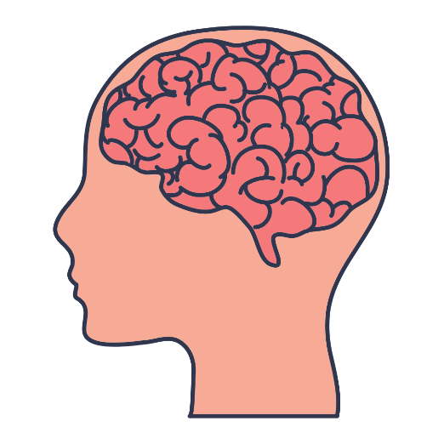 |  | Dementia is an illness caused by damage to a person’s brain.
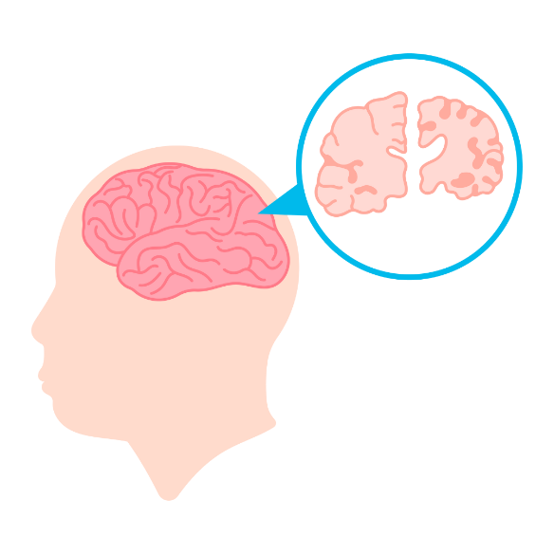 |  | Cells in the brain die.  They cannot grow again.
 |  | Damage to the person’s brain makes it hard to remember, think and do things.
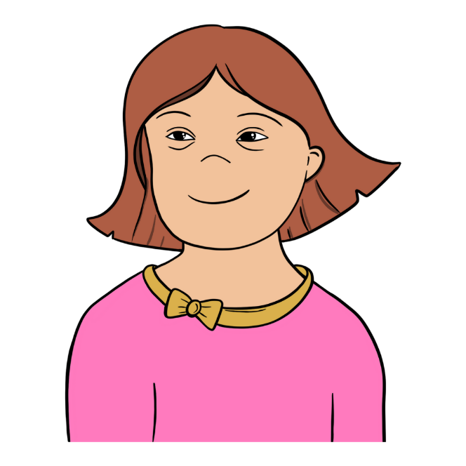 |  | People with learning disabilities are more likely to get dementia.
East Lothian Dementia Strategy
 |  | East Lothian Health and Social Care Partnership supports people with dementia in East Lothian.
It has made a plan about how to support everyone with dementia in East Lothian.

This is called the East Lothian Dementia Strategy.
What the plan says
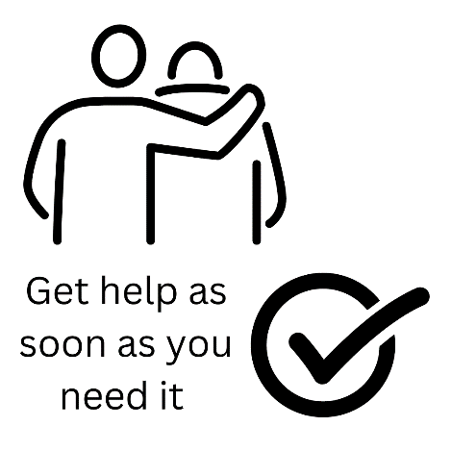 | The plan says people with dementia should get the help they need when they need it
People who are worried they have dementia should see their doctor.

The doctor will arrange for the person to have tests to see if they have dementia.

If the tests say that they have dementia, this is called a ‘diagnosis of dementia’.

People should get their diagnosis quickly.
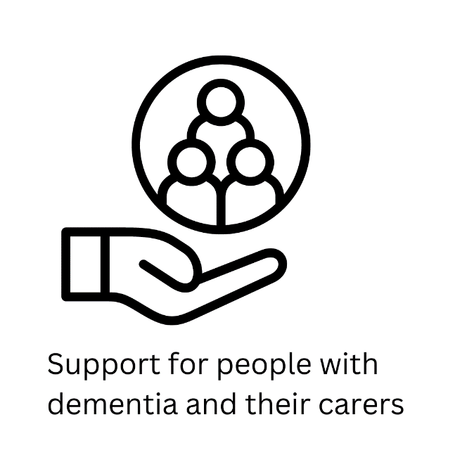 | People with dementia and their carers should get support as soon as they have a dementia diagnosis.
 | People with dementia and their carers should be able to find out how to get help easily.
 | People with dementia should be independent for as long as they want to be.
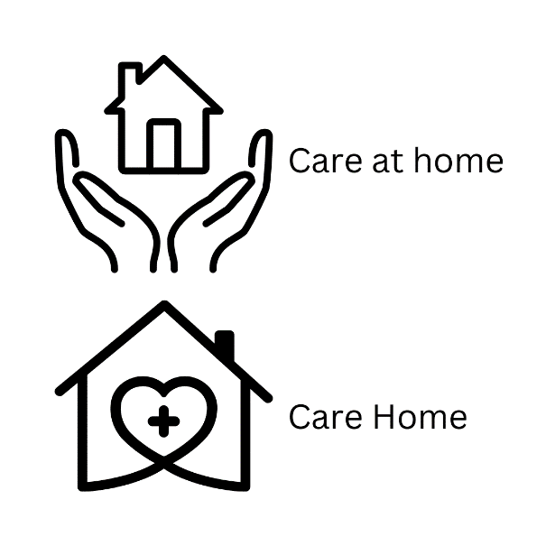 | People with dementia should get care at home as soon as they need it.  People with dementia should be able to live in a care home if they want to.
 | More people with dementia will be able to get hospital treatment at home or at East Lothian Community Hospital.

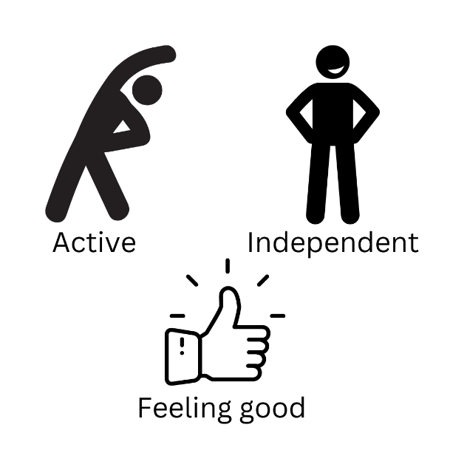 | The plan says people with dementia should be active and independent.  The plan says that people with dementia should be able to do what is important to them.
 | Communities in East Lothian should be dementia friendly.
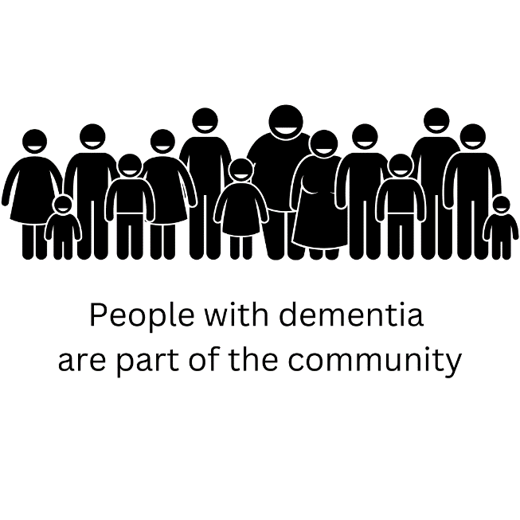 | Communities and businesses should think about what people with dementia need.  They should make community activities welcoming for people with dementia.
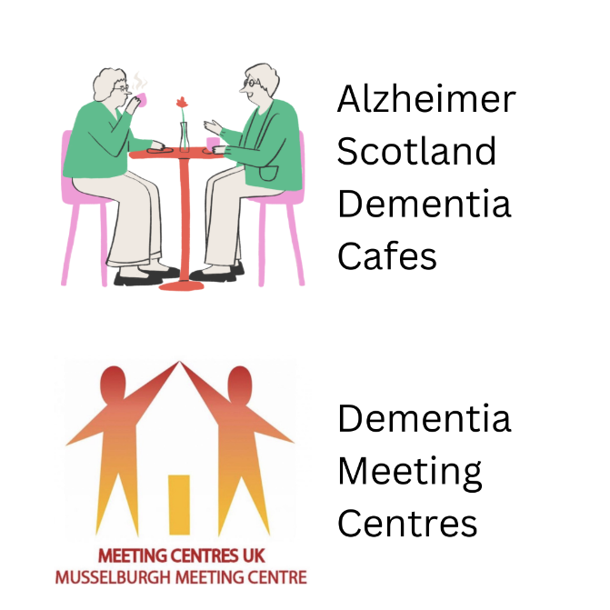 | We want to have more places where people with dementia can go to be together.  We want to have more Dementia Cafes and Dementia Meeting Centres.
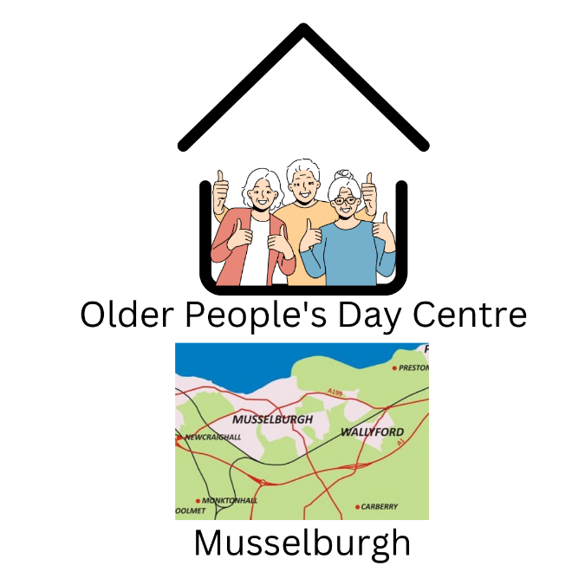 | We want to make sure that Musselburgh has a day centre.
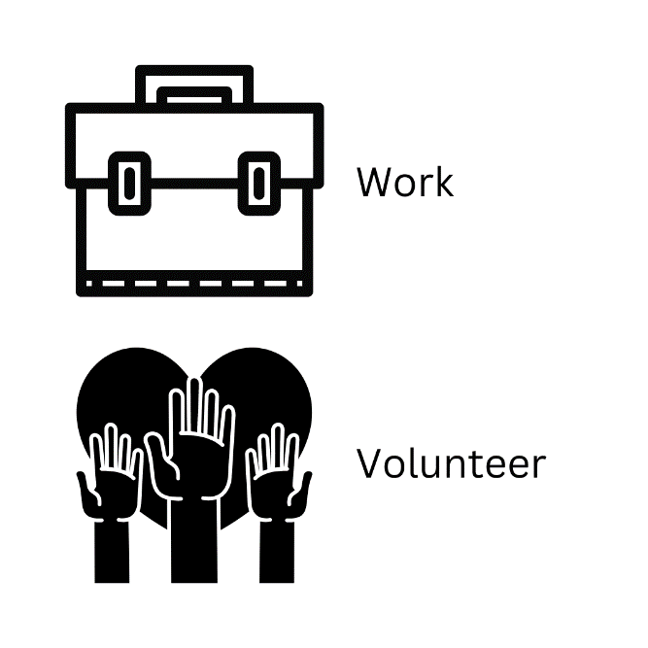 | We want people with dementia to be able to work if they want to.  We want people with dementia to be able to volunteer and help others if they want to.
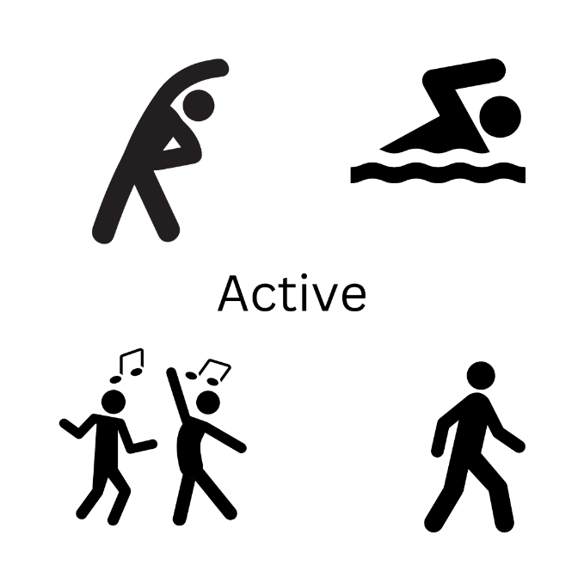 | We want people with dementia to stay active.  We want community and leisure activities to welcome people with dementia.
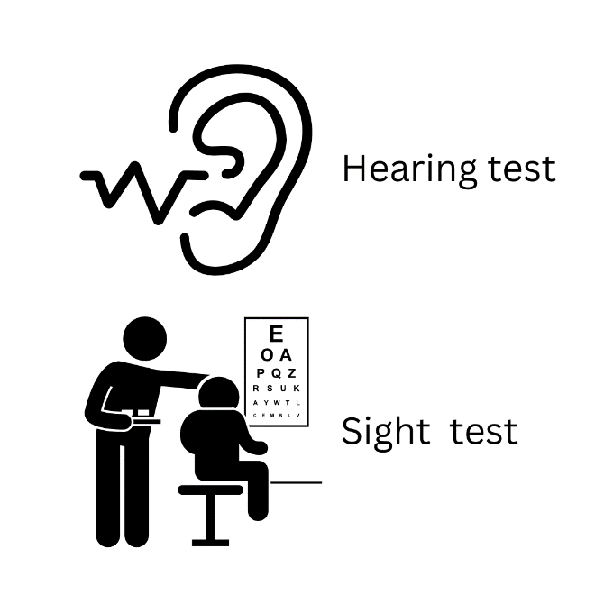 | It is very important for people with dementia to have their hearing and sight tested.  We are going to make sure that everyone knows about this.

 | We want people with dementia to plan ahead as much as possible
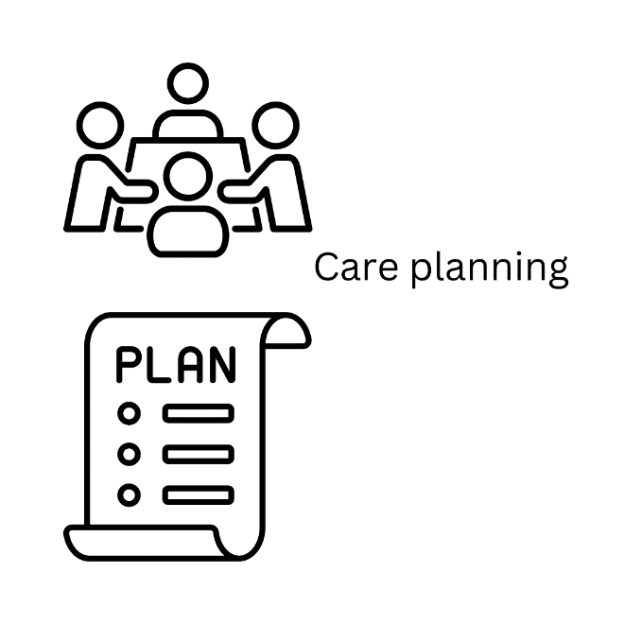 | People with dementia and their families or carers should be very involved in planning what care they are going to get.  It is very important that the wishes of the person with dementia are heard.  The plan should think about the things that are important to the person with dementia.
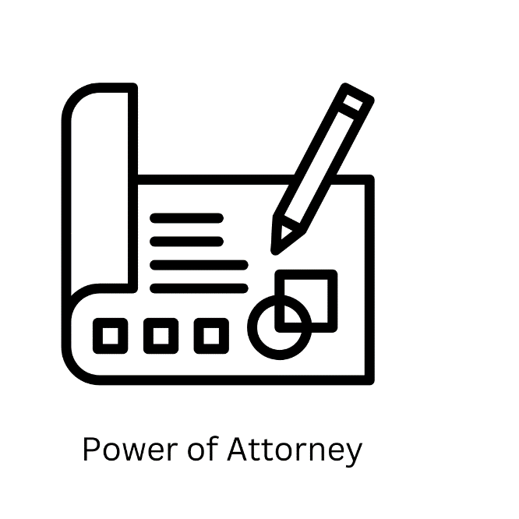 | We’d like people with dementia and their families and carers to plan ahead.  We would like people with dementia to talk to a solicitor about getting a Power of Attorney.  This is a legal document. It lets someone with dementia say who they want to look after their money and make decisions about their health and care.  We want to make sure that people with dementia are able to say what they want to happen as their dementia gets worse.

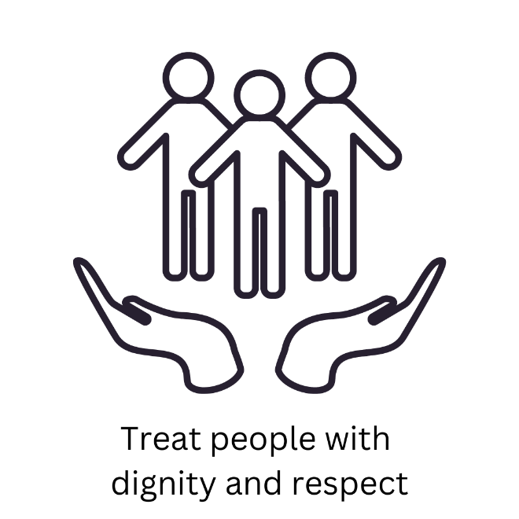 | The plan says that we want everyone to treat people with dementia with dignity and respect
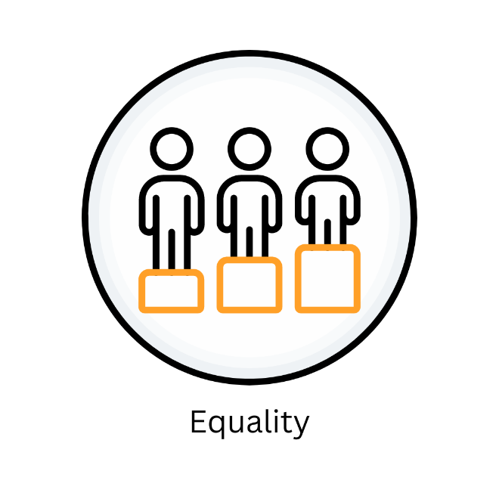 | Everyone is different but everyone has the same right to be treated fairly.  We want to make sure that no one is left out.  We want to make sure that there is suitable help and support for everyone.
Staff working with people with dementia must have training about dementia.

We are going to make sure that all our staff have the right training.

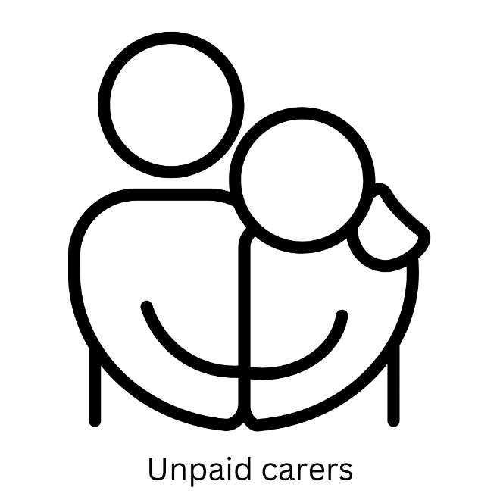 | The plan says that unpaid carers are important too.  Unpaid carers include family members, friends or neighbours who look after people with dementia.
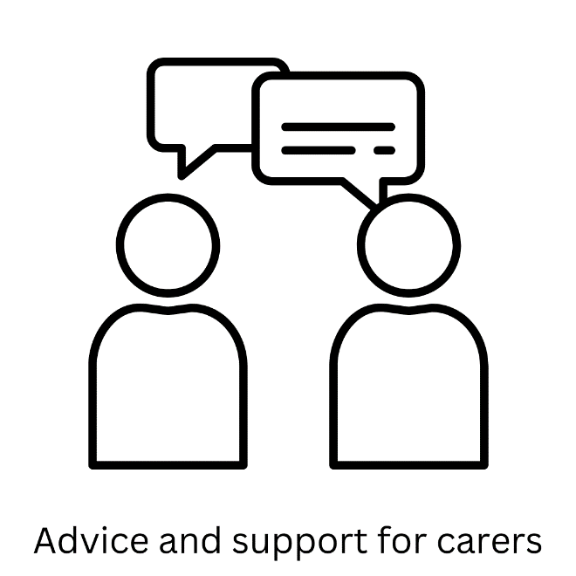 | No matter much families or friends want to look after people with dementia, sometimes they needs help.  Our staff will offer advice and support when carers need it.
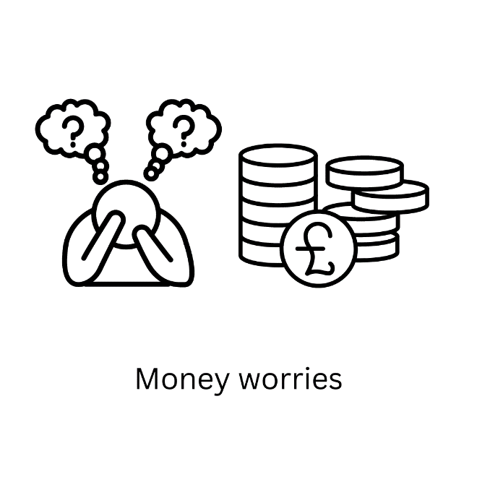 | Sometimes unpaid carers are really worried about money.  This might be because they have had to stop working.  We will make sure unpaid carers get support to get all the money that they are entitled to.
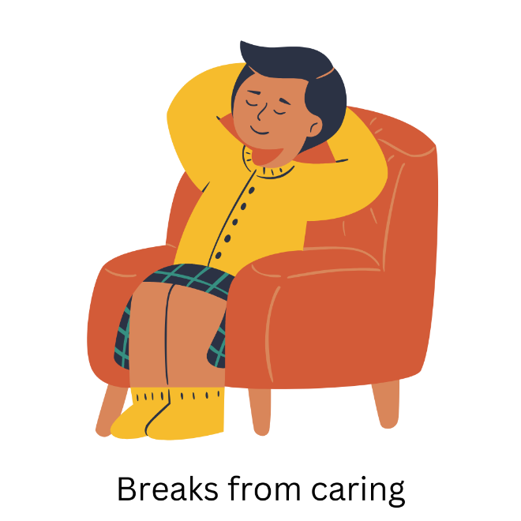 | Being an unpaid carer is hard work.  Sometimes unpaid carers need a break from caring.  We want to make sure that unpaid carers get breaks.  Carers might want to use this time to do something that interests them or just to have a rest.

