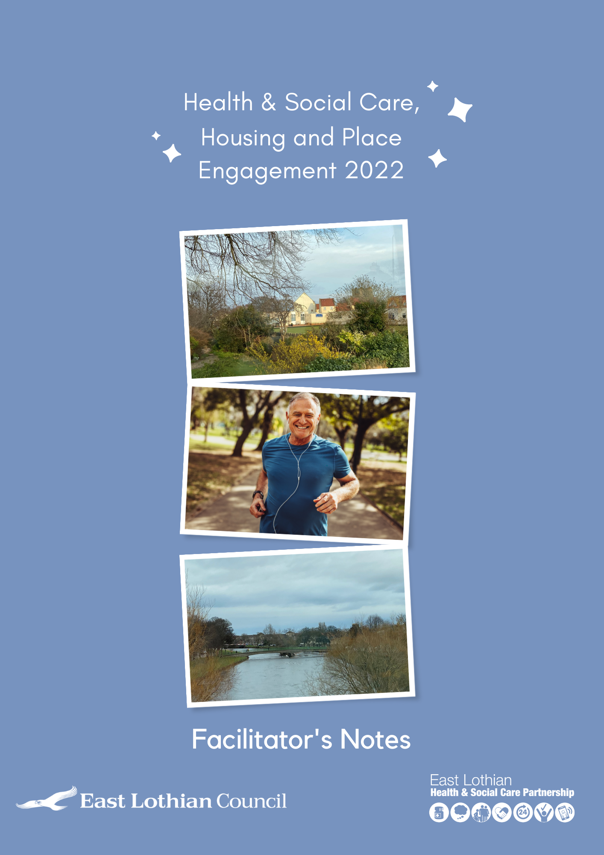

Facilitator Notes

Health and Social Care, Housing and Place Engagement

Introduction
These bullet points are suggestions for helping you to run the engagement. You may not need them, but we hope they are a useful guide to setting the scene.
- Start with, ‘Let’s briefly introduce ourselves’ – who we are, what we do
- Set out the format for the engagement:
- In this engagement meeting, we are going to think about three areas that impact us all – health and social care, housing and the area that we live in
- So, there will be three sessions, one for each topic
- If there are a lot of people attending, then we’ll break up into smaller groups (maybe around 10 people in each, so everyone has a chance to speak and be heard)
- There will be a short video to start each session off, setting the scene for your discussion
- Then we will work through five questions in each session that will look at your experiences now and what you think is important for the future.
- At the beginning of the session, I will remind you of what time you need to end each session and move on to the next, so if we allocate 40 minutes for each session, the engagement meeting should take around two hours
- Appoint a scribe for each group or session
- Perhaps, after viewing the relevant video, start each session with ‘To help keep us keep to the time allocated, I will go round each of you and ask you to give your succinct first thoughts’
- If you want to say more about any of the topics, you can send additional thoughts and notes back with your recording sheet.
Please note: if your group is keen to spend longer on the sessions or do them as longer, discrete units over two or three meetings, that would be great. We’d like you to use the format in the way that best meets the needs and interests of your group. But we would really like to hear from you on each topic, if possible, and please use the relevant recording sheets so we can ensure consistency.
We’d also be happy if you would prefer to share the video links with attendees/potential attendees before the meeting if that would suit your timings better.

The questions
In each group, we will ask you to consider:
Thinking about health and social care/housing/the local development plan:
- What matters to you most now?
- What about the future?
- What’s going well and why?
- What could be better and how?
- What else would make a difference?
At the end of the session, please thank everyone on behalf of the Council and the Partnership for their time and let them know that their feedback will be used to inform the development of the:
- Integration Joint Board Strategic Plan
- The East Lothian Local Housing Strategy
- The Local Development Plan.
We will try to give you regular updates on the feedback we receive from all the groups involved, and would like to invite everyone who has taken part to join our Big Conversation event on Microsoft Teams at the end of May, at which we will look at key themes from the engagement and what happens next.
If you are interested in attending the Big Conversation event, please email us at elhscp@eastlothian.gov.uk to register your interest and to receive details and a meeting link in due course.

Thank you very much for taking part

