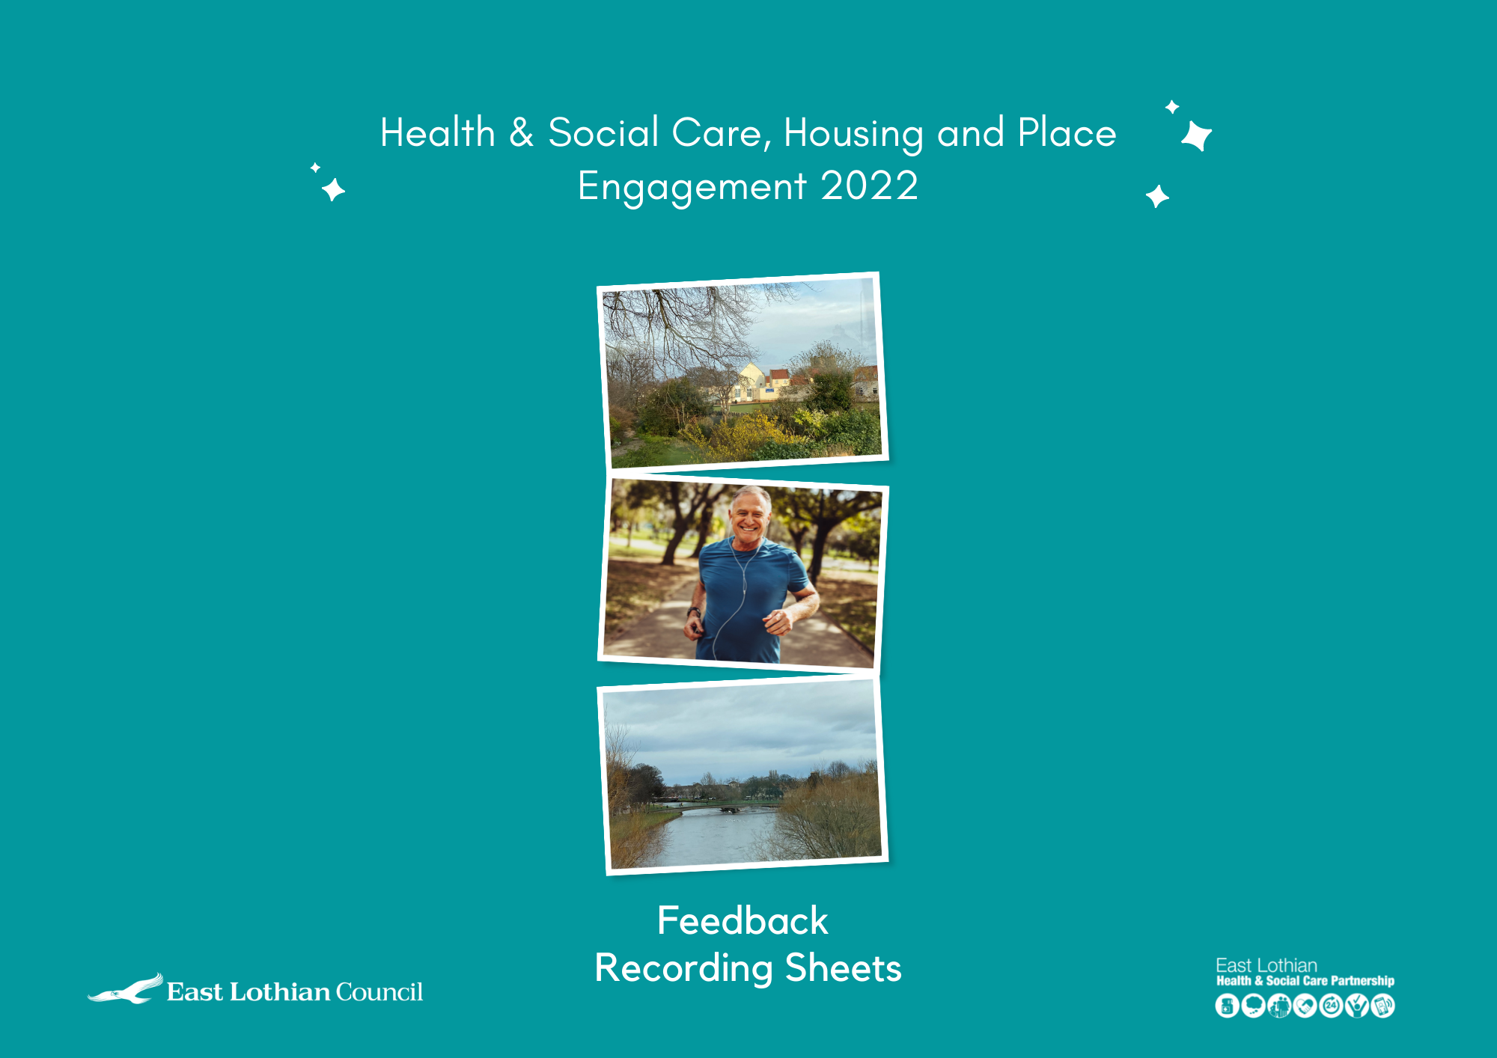
Event date:
Organisation’s name
Participant’s name | Contact details | Interest in engaging further – Yes/No
Recorded by:
Health and Social Care – please use this form to tell us about the key themes emerging from your discussions
Question 1: What matters most now?
Record your feedback here:

Health and Social Care – please use this form to tell us about the key themes emerging from your discussions
Question 2: What about in the future?
Record your feedback here:

Health and Social Care – please use this form to tell us about the key themes emerging from your discussions
Question 3: What’s going well and why?
Record your feedback here:

Health and Social Care – please use this form to tell us about the key themes emerging from your discussions
Question 4: What could be better and how?
Record your feedback here:

Health and Social Care – please use this form to tell us about the key themes emerging from your discussions
Question 5: What else would make a difference?
Record your feedback here:

Housing – please use this form to tell us about the key themes emerging from your discussions
Question 1: What matters most now?
Record your feedback here:

Housing – please use this form to tell us about the key themes emerging from your discussions
Question 2: What about in the future?
Record your feedback here:

Housing – please use this form to tell us about the key themes emerging from your discussions
Question 3: What’s going well and why?
Record your feedback here:

Housing – please use this form to tell us about the key themes emerging from your discussions
Question 4: What could be better and how?
Record your feedback here:

Housing – please use this form to tell us about the key themes emerging from your discussions
Question 5: What else would make a difference?
Record your feedback here:

Place – please use this form to tell us about the key themes emerging from your discussions
Question 1: What matters most now?
Record your feedback here:

Place – please use this form to tell us about the key themes emerging from your discussions
Question 2: What about in the future?
Record your feedback here:

Place – please use this form to tell us about the key themes emerging from your discussions
Question 3: What’s going well and why?
Record your feedback here:

Place – please use this form to tell us about the key themes emerging from your discussions
Question 4: What could be better and how?
Record your feedback here:

Place – please use this form to tell us about the key themes emerging from your discussions
Question 5: What else would make a difference?
Record your feedback here:

Returning your Recording Sheet
You can type into the recording sheet or fill it in by hand – whatever suits you best. If you are typing into the recording sheet, the boxes should expand to accommodate your text.
If you are doing this by hand and you don’t have enough space, please continue on another piece of paper and remember to include a heading about the particular theme and question your feedback relates to.
When recording sheets are ready to return to us you can:
- Email the filled in Word document to elhscp@eastlothian.gov.uk
- Scan your recording sheets and email them to elhscp@eastlothian.gov.uk
- Post them to:
Health, Housing and Place Engagement
Room 211
John Muir House
Brewery Park
Haddington
EH41 3HA
- Drop them off to any local council office in an envelope marked with the address above, and ask Customer Services to return it to us for you via internal mail.

Thank you very much indeed.

