UK Parliamentary Boundary Changes – Lothian East
Current polling districts ELMN1A, ELMN1B and the majority of ELMN1C will move to Edinburgh East Burgh. The following streets, within ELMN1C, will remain with Lothian East:

St Annes Convent, 8 Windsor Gardens
Ashgrove
Beulah
Linkfield Court
Linkfield Road – numbers 1-32
Foresight Residential Ltd, Linkfield Road
Victoria Terrace, Linkfield Road
Millhill – 1 Millhill
Pinkie Road – numbers 40 and 42
Windsor Gardens
Woodside Gardens

More information on the 2023 Review of UK Parliament Constituencies can be found here.

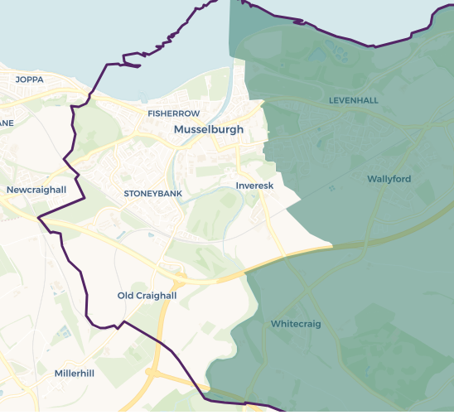
The shaded area shows the new boundary for Lothian East.

