Early Learning & Childcare Team
East Lothian Council John Muir House, Brewery Park, Haddington, East Lothian EH41 3HA
Early Learning & childcare Family Consultation February 2024
Birth – Two Years & Prospective Families

[Cite your source here.]

Introduction

In October 2016, the Scottish Government published ‘A Blueprint for 2020: The Expansion of Early Learning and Childcare (EL&CC) in Scotland’, setting out the vision to expand the entitlement of funded EL&CC. The funded hours increased from 600 hours to 1140 hours per year for all three and four-year-olds and eligible two-year-olds from August 2020. The aim was to provide high quality, flexible EL&CC which is accessible and affordable for all families.
Since 2017, East Lothian Council began the process of delivering 1140 funded hours of EL&CC in pilot settings and this was fully implemented across the authority by 2021. East Lothian Council offer a range of EL&CC options including Local Authority, Funded Provider settings, and Childminder settings. These settings aim to offer high quality learning experiences and flexible hours that suit families’ needs.
This consultation collated the views from prospective families and families with children aged 0-2 years across East Lothian.
Families with children aged 2- 5 years were invited to respond to a consultation in November 2023 and this report can be found at: East Lothian Council - Citizen Space (eastlothianconsultations.co.uk)
For the purposes of this report, we define Early Learning & Childcare as the funded 1140 hours provided at East Lothian Council EL&CC settings and Funded Providers, which include private nurseries, childminders and third sector groups.

Statutory consultation for prospective families & families of children 0-2 years– January 2024

Local authorities have a statutory duty to consult every two years on the provision of EL&CC to inform the planning and delivery of services. We also have a duty to publish the Local Authority plan for the delivery of EL&CC. These plans will set out the comprehensive strategic direction for the delivery of EL&CC across East Lothian
East Lothian Council (Education and Children’s Services) consulted with the public about EL&CC in January 2024. This consultation provided an opportunity for families of children 0-2 years and prospective families to share their views on current models, flexibility, and systems of choice.

We would like to thank all those who took the time to participate in the consultation and East Lothians partner agencies for promoting our survey. The consultation will help us to understand how families would like EL&CC to be delivered in the future. Results for specific geographical areas will be analysed in more detail to inform the development of Local childcare services and any improvements that can be made to the accessibility and flexibility of the EL&CC options available.
The online survey asked for views of families on:
- What (if any) childcare do you currently use for your child
- Reasons for attendance
- How you would like to access your child's future EL&CC entitlement
- Choosing a future EL&CC setting for your child
- Choosing a future model preference for your child

Overview of Respondents
- 778 responses were received across from families across East Lothian (Fig 1)
- 94% of respondents were female (Fig 2)
- 53% of responses came from households of a child aged 2 or under with other siblings, 30% from households of children aged 2 or under, 15% from prospective first-time families and 2% from carers of children aged 2 or under (Fig 3)
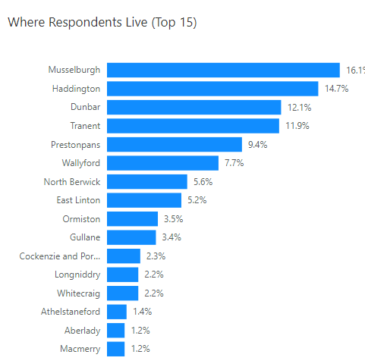
- 83% of responses came from respondents who’s primary reasons for using their eligible funded childcare hours is to return to full or part time work (Fig 3A)
FIG 1

FIG 2
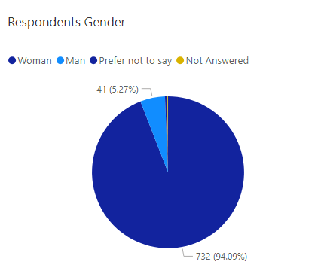

FIG 3
FIG 3A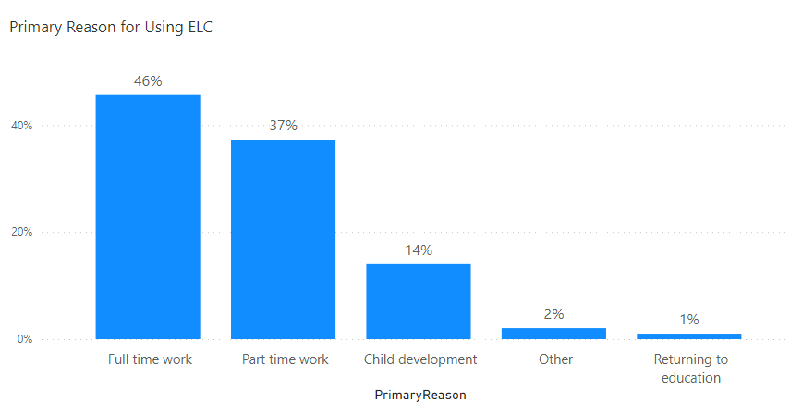

Current Childcare Arrangements
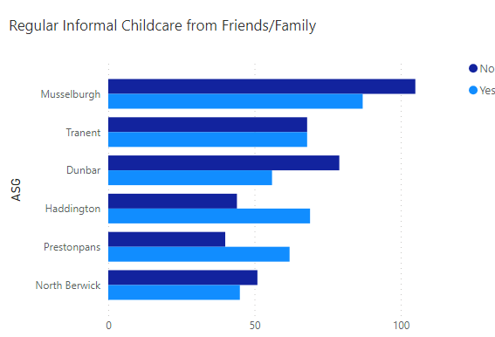
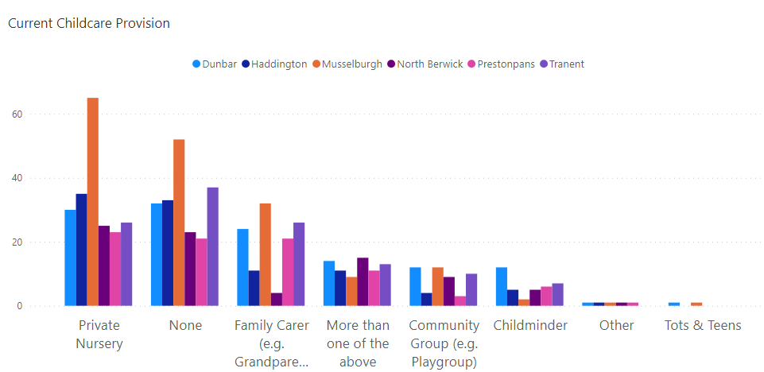
- 25% of respondents with children under 2 years of age said they do not currently use any childcare, 26% use a Private Nursery, 15% have family support, (e.g., grandparents) 5% use a Childminder and 9% use a mix of different childcare options (Fig 4 & 4A)

Fig 4
Fig 4A

- 37% of respondents said they hope to use a 48-week local authority EL&CC setting, with various attendance patterns (Fig 6)
- 26% of respondents hope to use a Private Funded Provider setting with flexible hours and options to pay for additional childcare hours
- 25% hope to use a 38 week (Term Time) Local Authority setting, offering a Monday – Friday model
- The remaining respondents selected the use of a funded childminder or a blended model of childcare options. E.g., Nursery and Childminder or will fund their own childcare
- 65% of respondents said they would pay for additional childcare hours above their eligible funded hours (Fig 7)
- Respondents’ primary reasons for using EL&CC settings is to enable them to work full or part time (Fig 7A)
- 62% of respondents said that locality was the main reason for their preferred future choice of an EL&CC setting, 43% said catchment was a main factor, 23% liked the idea of their child being at a Funded Local Authority setting, 22% preferred choice, flexibility and options to pay for additional hours at a private Funded Provider setting and 20% said model choice will be a main reason for their choice of setting (Fig 8)
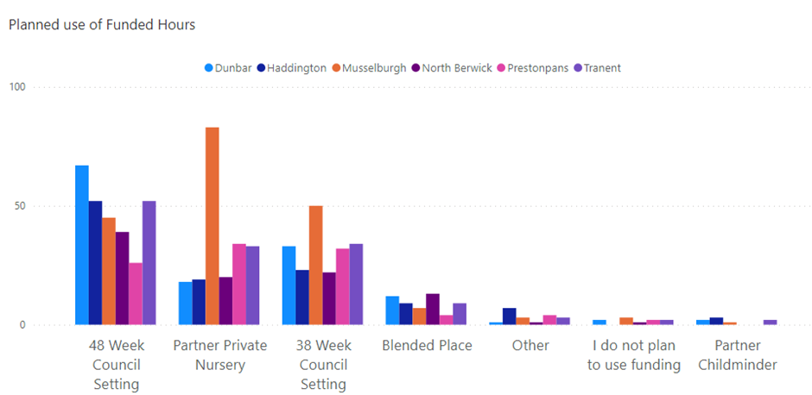
- Respondents selecting a 48-week EL&CC setting, were asked what model choice they may choose, 63% said they didn’t know yet, the remaining respondents selected the three- and four-day model as a preference (Fig 8A)
Fig 6
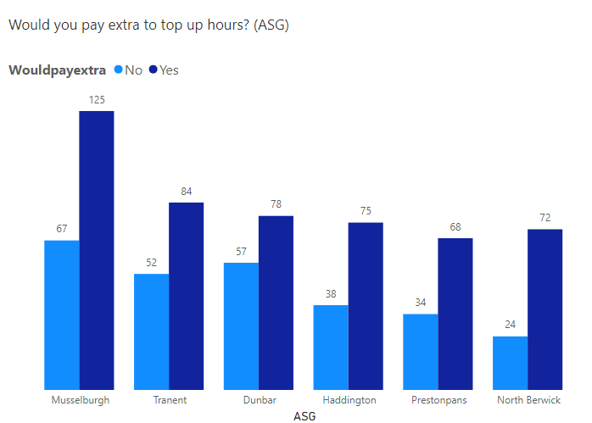
FIG 7
Fig 7A
FIG 8

FIG 8A

Eligible 2 Funded Childcare hours
- Respondents across all Localities were asked if they met the Eligible Two funding criteria, 82% said they did not, 9% said they did qualify and 8% of respondents were unsure (Fig 9) Eligible Two year old criteria
- Majority of respondents that selected yes to qualifying for eligible two funded hours, selected 48-week, 38 week or Private Funded Provider Nursery as their preferred choice of setting for their child to attend (Fig 10)
FIG 9
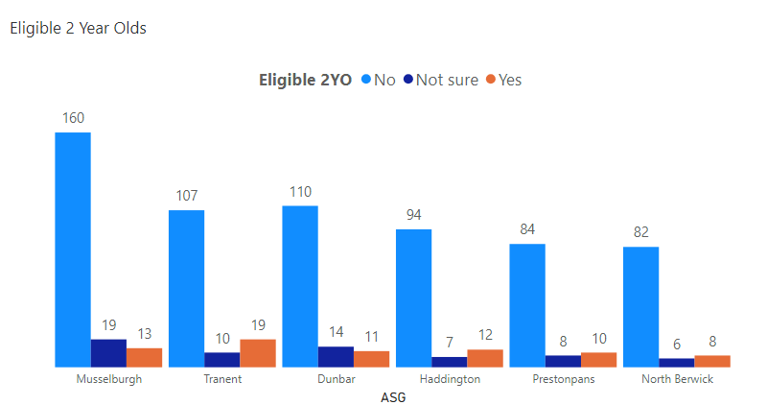
Fig 10
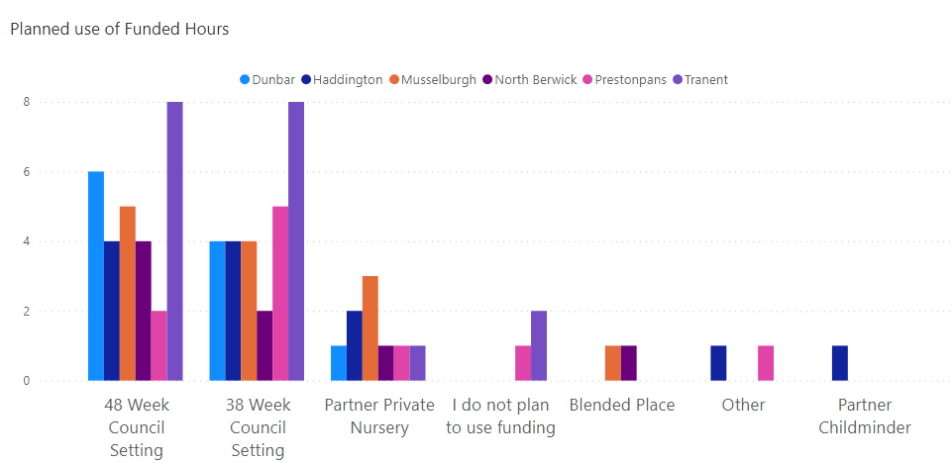
Overall themes, considerations, and recommendations

This consultation gathered 778 responses from families and included responses across all localities. The feedback received, told us that most families with children aged 2 and under, primary reason for using EL&CC is to enable them to work on a full or part time basis. The highest number of responses received came from families with 1-year olds, and data gathered shows that most children under the age of 2 are already attending EL&CC settings or being cared for by family relatives or friends.
Responses indicate that families require a choice of models and options across East Lothian, with locality being the main reason for their choice. Most respondents who selected a 48-week Local Authority setting as their future choice of childcare were unsure what model of days would suit them best at the time of completing the consultation.
The data collated has highlighted that a large proportion of respondents are unaware of what funded childcare is available to them or if they qualify for Eligible Two funding.
Majority responses show that while families will be using their funded childcare hours when their child becomes eligible, they do not know yet what they will require, and family personal circumstances will be a significant factor when choosing a future place for their child. The majority of the respondents would like the option to be able to pay for additional childcare hours to top up their funded entitlements.
The intention of the survey was to identify areas that may need further consideration and review. The following recommendations for action are to:
  - Review the EL&CC models that are available, along with families’ views and data collated from the survey
  - Understand the impact of model changes on children’s uptake of EL&CC entitlement
  - Continue to review the EL&CC capacity across all settings, including Funded Provider Nurseries, Childminders and Third Sector settings
  - Consider how we raise awareness to prospective families about their child’s entitlements, the range of provision available, and how they access this

Future surveys will continue to be representative and inclusive; we will continue to liaise with wider professionals across the authority to capture family’s views and needs.

