Eligible Two & Three – Five Year olds
East Lothian Council John Muir House, Brewery Park, Haddington, East Lothian EH41 3HA
Early Learning and Childcare Family Consultation November 2023

Introduction
For the purposes of this report, we define Early Learning & Childcare as the funded 1140 hours provided at East Lothian Council Early Learning and Childcare settings, Funded Provider Nurseries, Funded provider Childminders and third-party settings
In October 2016, the Scottish Government published ‘A Blueprint for 2020: The Expansion of Early Learning and Childcare (EL&CC) in Scotland’, setting out the vision to expand the entitlement of funded EL&CC. The funded hours increased from 600 hours to 1140 hours per year for all three and four-year-olds and eligible two-year-olds from August 2020. The aim was to provide high quality, flexible EL&CC which is accessible and affordable for all families. The statutory requirement for local authorities to deliver this entitlement was postponed to August 2021 due to the Covid-19 pandemic.
In 2017, East Lothian Council started the process of delivering 1140 funded hours of EL&CC in pilot settings and this was fully implemented across the Local Authority by 2021. East Lothian Council offer a range of EL&CC options including Local Authority, Funded Provider settings, Funded provider Childminder settings and third-Party settings. These settings aim to offer high quality learning experiences and flexible hours that suit families’ needs.

Statutory Consultation – November 2023
Local authorities have a statutory duty to consult every two years on the provision of (EL&CC), to inform the planning and delivery of services. East Lothian Council (Education and Children’s Services) consulted with the public about EL&CC in November 2023.
We would like to thank all those who took the time to participate in this consultation. The consultation will help us to understand how families would like EL&CC to be delivered in the future. Results for specific geographic areas will be analysed in more detail to inform the development of local childcare services and any improvements that can be made to the accessibility and flexibility of the EL&CC options available.
The online survey, asked for views of families on:
- Choosing an EL&CC setting.
- Reasons for attendance.
- How you will be accessing your child's EL&CC entitlement.
- Preferences of the current delivery models available to access the funded entitlement of EL&CC.

Overview
- 434 people responded to the 2023 EL&CC consultation
- 58.1% of responses were received from families using a 48-week Local Authority EL&CC setting, 13.8% came from Funder Provider settings, 11.5% from 38-week Local Authority settings, 9.1% from blended places (Fig 1). The remaining 7.4% of responses were split between families using other arrangements, such as family carers, self-funded childminders, and community groups
- The largest numbers of responses received were from families of eligible 3–5-year-olds (Fig 2)
- Responses were gathered into associated school groups (Fig 3)
- Responses were received from 18 Localities in total, of which the chart shows the top ten (Fig 4)
- 31% of respondents say they currently pay for additional EL&CC hours and 54% of respondents say they would like the option to pay for additional hours above their funded entitlement
(Fig 1)
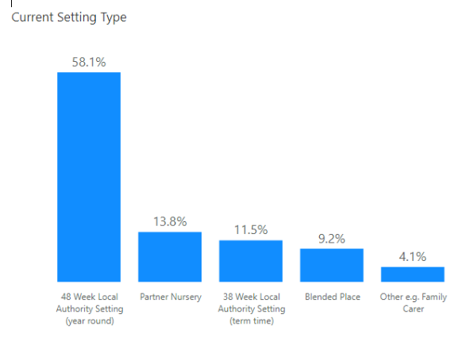

(Fig 2)

(Fig 3)
Where Respondents live
(Fig 4)

Family Choice
- 78.8% of 411 respondents who answered the question said they received their first choice of setting (Fig 5).

FIG 5
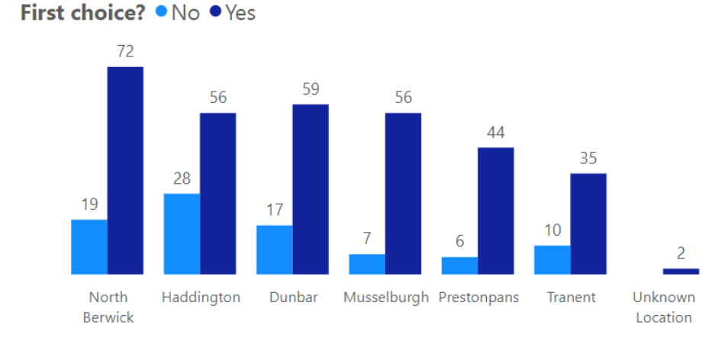

Primary reasons for using an Early Learning & Childcare setting
- 61.5% of respondents use their funded EL&CC hours whilst in full or part time work (Fig 6).
- 30% of respondents use their EL&CC funded hours to support their child’s development.
- All six associated School groups (ASG) said their main reasons for choosing their child’s setting is because it is within their locality or catchment school area (Fig 7).
- 15 respondents said their child was in a setting because they didn’t have any other options available to them.
- Respondents in all six ASGs commented that having siblings at the same school and high-quality learning were also contributing factors when choosing which setting to use their EL&CC funded hours.
- Respondents also chose their child’s specific EL&CC setting based on:
- Being an excellent setting with high standards
- Familiarity with the school
- An intimate setting
- Flexibility
Fig 6
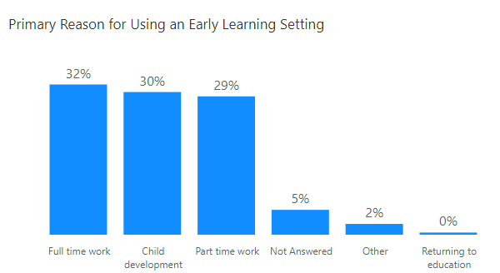

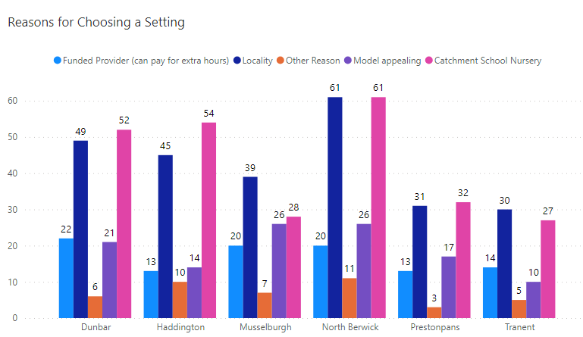
Fig 7

Model Choice
- 95% of respondents informed us what model of attendance their child currently access
- 75% of these told us the current model that their child attended was their preferred choice
- 20% of respondents told us they would prefer a different attendance pattern for their child
- 5% Did not answer
- In 48-week Local Authority settings the four-day model was the preferred choice for families and the two-day model was the least favourite

Overall Themes (All Models)
Consideration and Recommendations
The feedback received through this consultation shows that the primary reasons for accessing EL&CC is due to families being in full or part time work. 75% of families are satisfied with the EL&CC offer within East Lothian Council and those that were dissatisfied with the model were mainly within specific settings/areas
Responses show the complexity of decision making that families face when choosing an EL&CC setting and model for their child, taking into account their personal circumstances, preference, hours, availability, routines, and eligibility
The intention of this survey was to identify areas that may need further consideration and review. The following recommendations for action are to:
- Review the ELC models available, linked with families’ views from the survey
- Understand the impact of model changes on children’s uptake of EL&CC entitlement
- Plan further consultations to capture the views of families once new models are in place and existing models are embedded
- Consider how we raise awareness to families of their child’s entitlements, the range of provision available, and how they access this
- Continue to review the childcare capacity across all EL&CC settings, including Funded Provider Nurseries, Funded Provider Childminders and Third Sector settings
Future surveys will continue to be representative and inclusive; we will continue to liaise with wider professionals across the authority to capture family’s views and needs.

