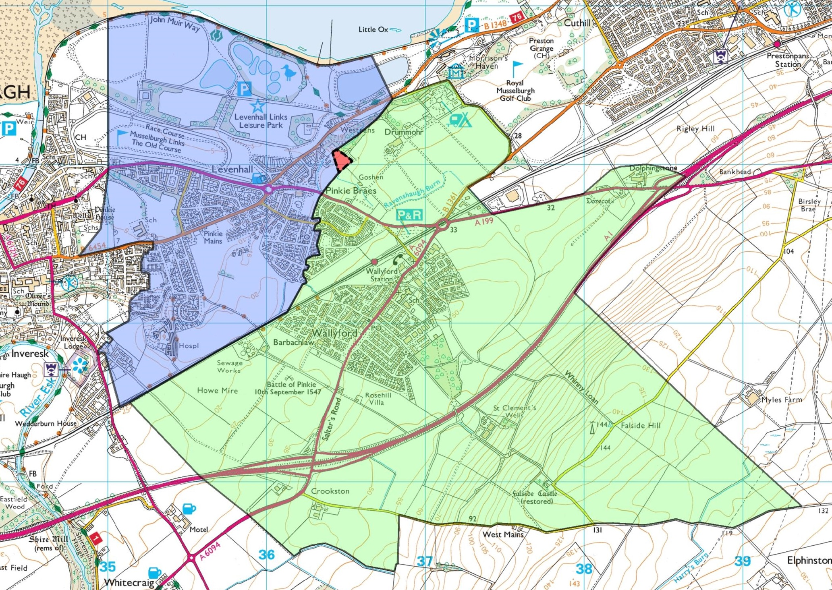

**“A” + “C” = Proposed Revised Pinkie St Peter’s Primary Catchment**

**“B” = Proposed Revised Wallyford Primary Catchment**

**Segment “C” = Proposed amendment; changed from Wallyford Primary Catchment to Pinkie St Peter’s Primary Catchment**

**Segment “C”**

B

A