East Lothian Council
Public Budget Consultation 2019-20

Transforming your Council
In recent years, East Lothian Council has sought to protect the vital public services which residents rely on. This has included action to help children achieve their potential, supporting older and vulnerable people, protecting the environment, investing in local facilities and working to build the East Lothian economy.
The Council has been on a prolonged journey of change and has reduced costs by more than £27 million over the last six years. However, like many other councils, we face significant reductions in government grant funding. The recent Financial Prospects report highlighted that East Lothian Council may have to make further savings of around £32 million over the next five years, over and above approved planned savings. This will mean that the Council is faced with some very tough choices and must consider how it can reduce costs, how it might increase income streams, do more with less, and in many areas, the way in which we currently deliver our local services will need to change.

What you need to know

- The estimated funding we expect to receive from the Scottish Government (71% of our total budget) and through Council Tax receipts and other income sources (24%) will not be enough to meet the increasing cost of services in the years ahead.

- This comes at a time of rising population growth and increased demand for services, particularly from younger and older people.

- Given the scale of the funding pressures, it is increasingly challenging to make the required level savings without having an impact on local services and doing things differently.

- That is why council officers are working on budget savings options which would enable the council to balance its budget – as we are legally required to do. These proposals continue to be in development and no decisions can be formally taken until Elected Members meet to agree our 2019-20 budget in February 2019.

Our challenges: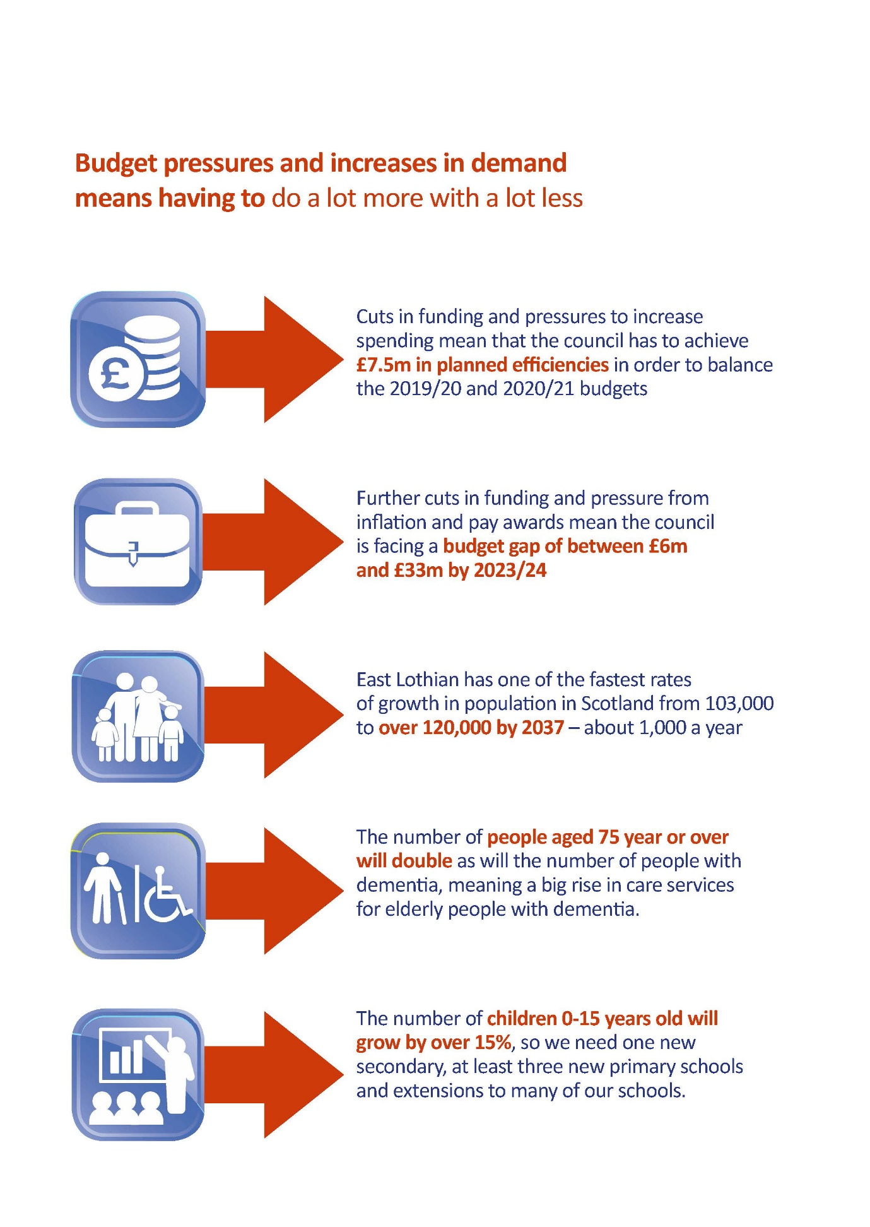

Other pressures:
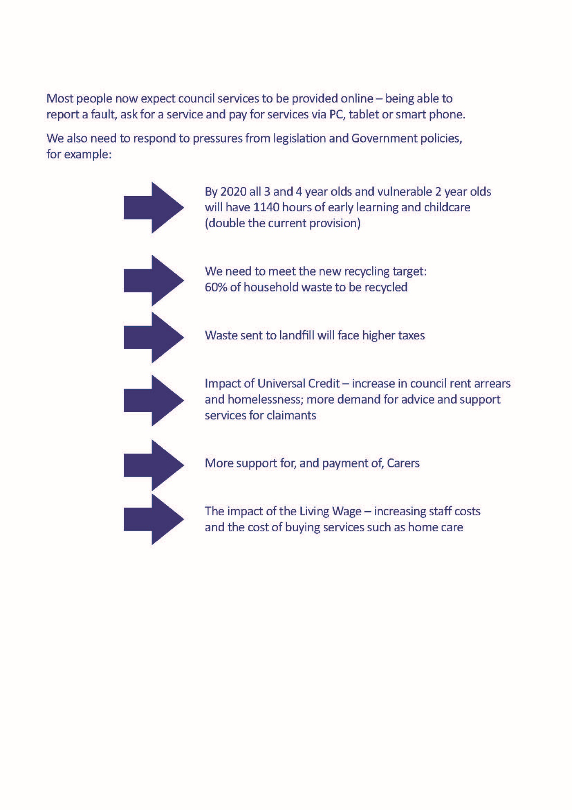

Our priorities
The Council Plan for 2017-2022 continues the journey towards realising our vision for an even more prosperous, safe and sustainable East Lothian, with a dynamic and thriving economy that enables our people and communities to flourish.
The overarching aim is ‘reducing inequalities within and across our communities’ with four themes each designed to make the biggest impact in our communities.
These are:
- Growing our Economy
  - Reduce unemployment
  - Improve the employment of East Lothian’s workforce

- Growing our People
  - Reduce the attainment gap and raise the achievement of our children
and young people
  - Improve the life chances of the most vulnerable people in our society

- Growing our Communities
  - Extend community engagement and decision making
  - Increase community and individual resilience

- Growing our Capacity
  - Deliver transformational change
  - Harness the opportunities technology offers in the provision of services

Where the money comes from:
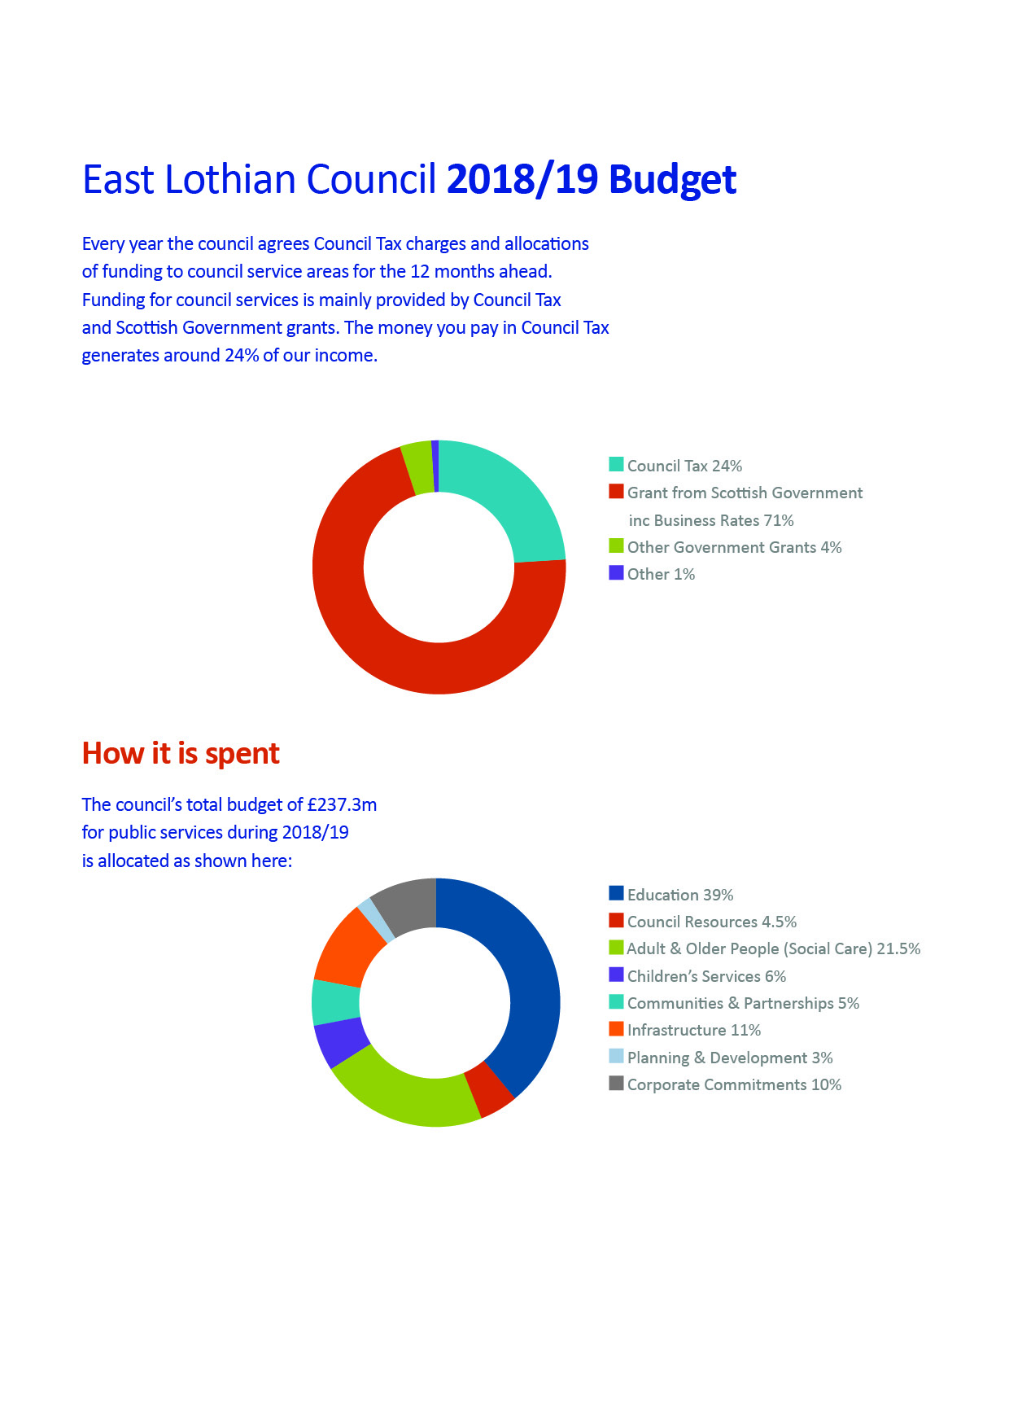

Where the money goes:
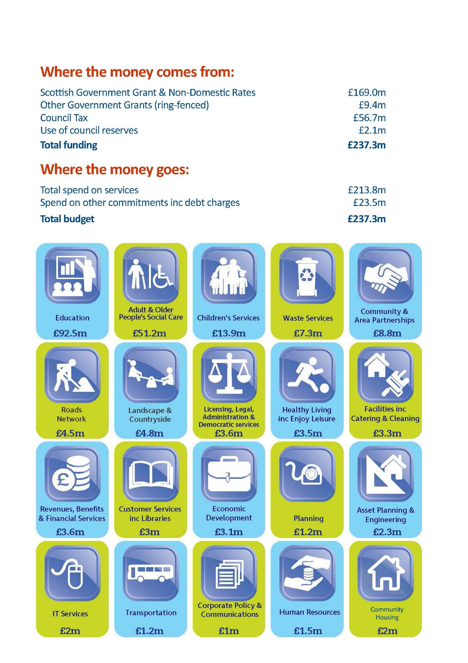

How the money was used in 2017-18:

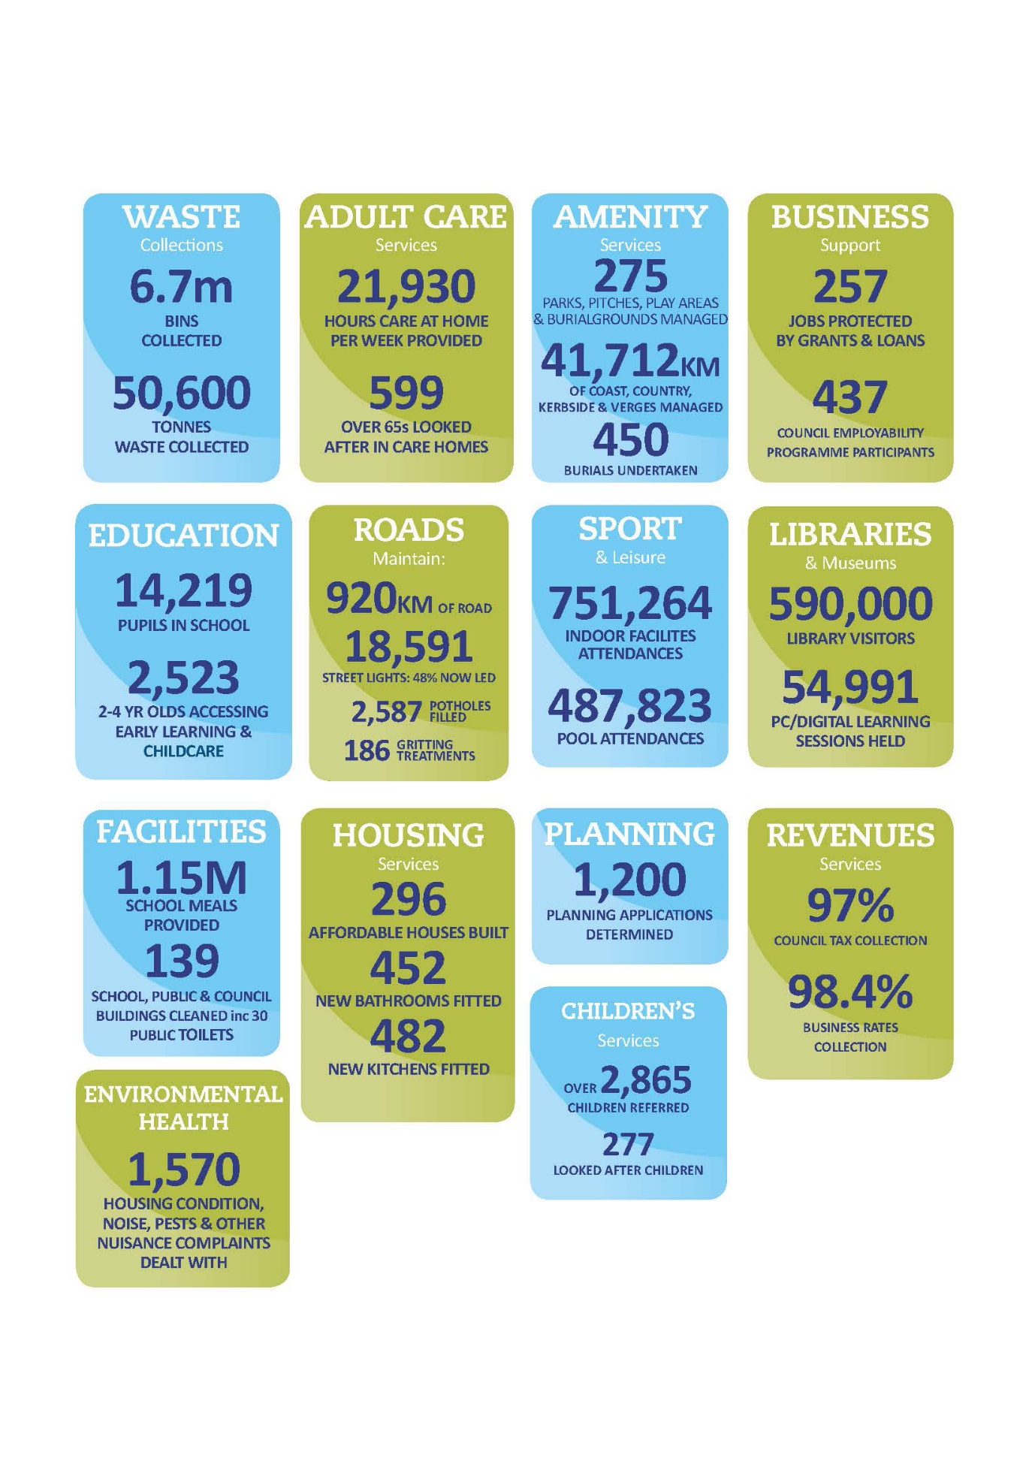

We want to hear your views

We want you to help us shape the local services which are important to you – while ensuring they can be delivered within the increasingly limited resources we have available to us.

Your views are really important to us, and it is important that every citizen across East Lothian has the right to have their views heard about the hard choices the Council is facing. We are looking for feedback on some of the budget proposals being considered, and also your views on the level of Council Tax which in part helps fund local services.

The Journey So Far

£27m savings from a variety of programmes and service reductions over the last 6 years including:

- Efficient Workforce Management

- Reviews of senior staff and structures – reduced senior staff by 30%
- Voluntary Early Release Scheme – 100 staff allowed to leave and not replaced (no additional payment beyond existing pension arrangement) (Saving = £3m)
- Services (and staffing) under review; for example, a Unified Business Support service bringing together admin and support staff from all services
- Overtime and use of Agency workers reviewed, monitored and kept to a minimum.

- No allowance for inflation on costs of supplies and services

- Any increase in costs of supplies and services are met through efficiencies, better procurement or buying less.

- Services redesigned or reduced

- Some posts shared with Midlothian Council
- New contract for home care services
- New waste collection service – weekly food waste collection (required by legislation) introduced along with changes in other bin collections

- Transformation / Change Programme

The Council has embarked on a Transformation/ Change Programme to change the way it does things to be more efficient and deliver services more effectively to meet the new demands and pressures.

This includes:

- Review of Council accommodation requirements and new ways of working, and working in partnership with other public agencies to make best use of our assets and provide a more joined up service.

- The redevelopment of the Council’s website and provision of on-line services. The new Council website to be launched in early 2018 will support on-line services and payments accessible from all mobile devices

- Exploiting new opportunities for income generation for example, exploring renewable energy sources, such as solar power

- Redesigning how services are provided, taking account of the potential to work in partnership with voluntary organisations, businesses and social enterprises, using ‘arms-length organisations’, trading companies, social enterprises and partnerships with other local authorities.

The Council’s Digital Strategy is fundamental to the Council’s Transformation/ Change Programme – putting services on-line so people can access them whenever they choose. The Strategy recognises that it is important to provide support to people who may be ‘digitally excluded’.

- Fees & Charges

The Council is currently reviewing what it is charging for and options for raising income, as well as exploring options to charge for new services. These charges are benchmarked with Scottish averages and other authorities.
It is proposed that all opportunities for charges be reviewed and that all existing charges be subject to an annual inflationary increase where appropriate.

Your views are important to us... How to take part

The budget consultation undertaken in December 2017 influenced the decisions taken by the council when it set its 2018/19 budget in February 2018. For example, the strong views against changes in home to school transport provision influenced the decision not to include this proposal in the budget. Fairly high levels of support for reducing the financial support for public events influenced the decision to include this proposal in the budget.
The Council will set its budget in the middle of February 2019, which is why we need you to have your say now on shaping the Council’s spending choices for 2019-20 and beyond.
You can also complete the questions online at: www.eastlothianconsultations.co.uk
Our consultation is open until Friday 21 December 2018
It’s your Council; you pay – now it’s time to have your say.

