2017-18
Draft Engagement Strategy
Consultation period – 3 March to 31 March 2017

Contents
 | Page
Introduction | 3
What does engagement mean? | 3
Participation, consultation and co-production | 3
Why is engagement key to all our work? | 4
East Lothian Health and Social Care Partnership Strategic Aims | 5

National Standards for Community Engagement
National Standard: Inclusion | 6
National Standard: Support | 7
National Standard: Planning | 7
National Standard: Working Together | 7
National Standard: Method | 8
National Standard: Communication | 8
National Standard: Impact | 9
Next steps | 9
Draft Action Plan | 10

Introduction
The Integration Joint Board (IJB) of East Lothian Health and Social Care Partnership is committed to improving outcomes for our population and for the communities in which people live. Our Strategic Plan describes this commitment and recognises that central to achieving our vision is the involvement of the different perspectives, skills, knowledge and resources of a broad range of people involved both in health and social care services and in our communities. The Strategic Plan values the richness and breadth of involvement and articulates a clear aim to build collaborative, meaningful partnerships between all key stakeholders.

What does ‘engagement’ mean?
Key to this work is understanding what we mean by the word ‘engagement’. The following section sets out our understanding.
Community engagement is about encouraging productive relationships between communities and public bodies. The National Standards for Community Engagement define community engagement as:
'Developing and sustaining a working relationship between one or more public body and one or more community group, to help them both to understand and act on the needs or issues that the community experiences'.
It is now accepted that public services that involve their users are likely to be of higher quality and more relevant to the communities they serve. The Scottish Government has built the principle of community engagement into policy and guidance to public services. This is most notable for Community Planning through which the Local Government Scotland Act requires all public services to work together. The guidance on the act states:
'Community Planning is essentially a process to secure greater engagement from communities in the planning and delivery of services'.
In addition, the Best Value 2 Community Engagement Framework produced by Audit Scotland emphasises the need for good quality community engagement practice at all levels and in particular in relation to:
- Commitment of organisations to engaging with communities
- How well organisations understand the needs and aspirations of communities
- How well communities are involved in decision-making
- How well communities are involved in planning, monitoring and evaluating services
- Demonstrating what community engagement has achieved

Consultation and co-production
- Consultation is the process by which people are asked their opinions. Consultation requires a commitment to listen, give due weight to the views expressed and feedback outcomes to the people consulted.
- Co‐production means delivering public services in an equal and reciprocal relationship between professionals, people using services, their families and their neighbours. Where activities are co‐produced in this way, both services and neighbourhoods become far more effective agents of change. [New Economics Foundation].

Figure 1: A model for community engagement
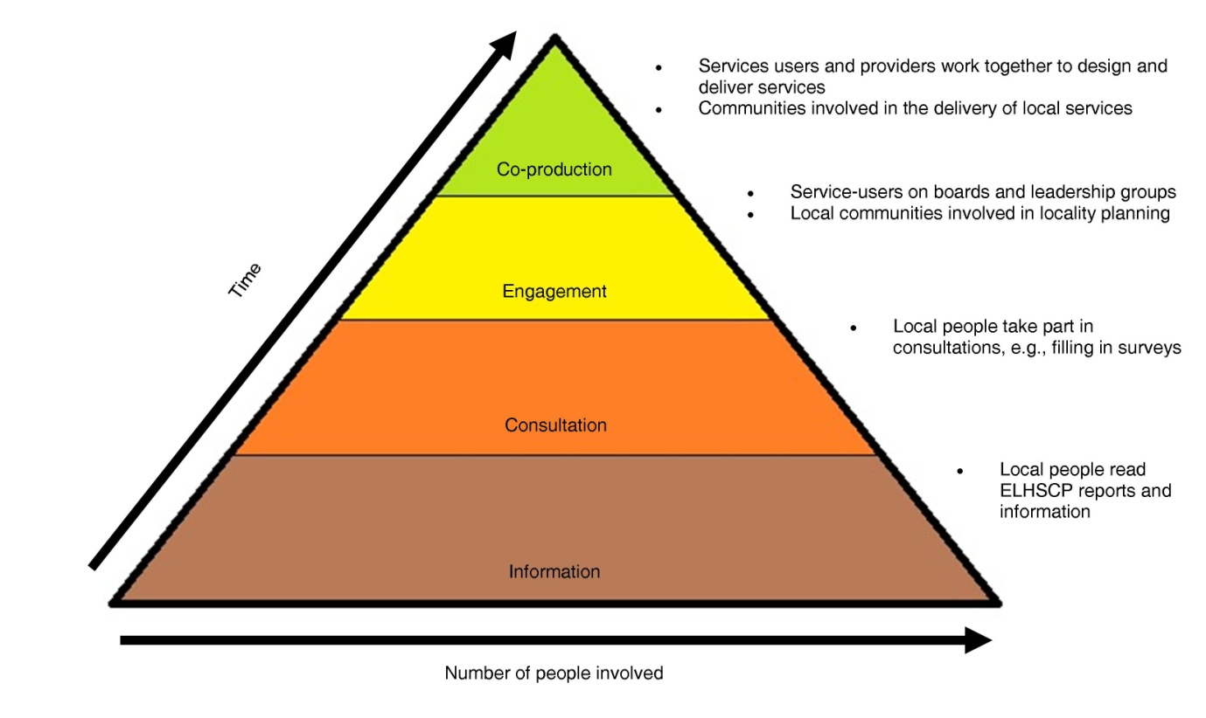

This strategy looks at consultation and engagement with the longer-term aim of achieving greater co-production.

Why engagement is key to all our work
The establishment of the East Lothian Health and Social Care Partnership offers huge opportunities to examine how health and social care partners in East Lothian can work together to streamline the way we do things, adopt more innovative practices and use the skills of a combined workforce to deliver even better outcomes for the people of East Lothian.

East Lothian Health and Social Care Partnership Strategic Aims

Best health, best care, best value for our communities
Our strategic aims are about ensuring that services:
Engagement with local communities, service-uses, carers, providers and other stakeholders is key to achieving every strategic aim. We want to learn from your experiences and work with you to achieve our vision of ‘Best health, best care, best value for our communities’. You can find out more about our vision for health and social care in East Lothian over the next few years in our strategic plan.

- are joined-up for service-users
- take account of the particular needs of individual service-users and their circumstances in different parts of the county
- respect our service-users’ rights and take account of their dignity
- take account of the way that our service-users participate in their communities
- protect and improve our service-users’ safety
- improve the quality of our services and ensure that they are planned and delivered locally in a way that is engaged with our communities
- anticipate needs and prevent them from happening
- make the best use of the available facilities, people and other resources.
Our Strategic Plan also commits to understanding the needs of the different communities in East Lothian, recognising that meaningful engagement and participation with individuals and communities requires us to take into account their individual and collective characteristics and in particular the protected characteristics of age, disability status, ethnicity, gender/sex, religion/belief, sexual orientation and transgender identity.

Engagement plays a key role
This Engagement Strategy is therefore one of our primary supporting documents and outlines how the IJB will:
- Ensure it has a clear and effective participation and engagement approach
at the heart of reforming health and social care services locally.
- Effectively deliver its Strategic Plan, which outlines how it will progress and
deliver on the agreed national health and wellbeing outcomes
- Enable the Partnership’s vision and how it works to become a reality
- Inform decision making processes in the carrying out of delegated functions.

National Standards for Community Engagement
We intend to work to the National Standards for Community Engagement. These are are good-practice principles designed to support and inform the process of community engagement, and improve what happens as a result.

Figure 2: National Engagement Standards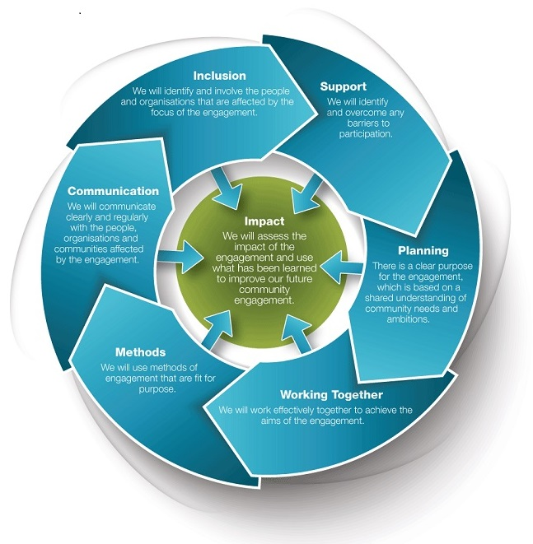

National Standard: Inclusion

We will identify and involve the people and organisations that are affected by the focus of the engagement

Our stakeholders
We are all stakeholders in health and social care. Therefore, as many of us as possible need to be engaged in strategic planning for health and social care in East Lothian. This includes through:
- Area Partnerships
- Community Councils
- East Lothian Tenants and Residents Panel and Tenants and Residents Associations
- Patient involvement groups
- Third-sector organisations
- Interest and advocacy groups
- Service-providers
- Community Planning groups (for example, Resilient People)
- Our staff and unions
- Elected members, MPs, MSPs
- Professional regulatory bodies.

National Standard: Support

We will identify and overcome any barriers to participation.
It is key that we remove or reduce any practical barriers which make it difficult for people to take part in engagement activities.
Examples of support issues to be addressed include:
- Suitable transport
- Caring for dependants (for example, childcare or care of older people)
- Personal assistance or personal care
- Suitable and accessible venues and appropriate catering
- Access to interpreters
- Communication aids
- Meetings and events organised at appropriate times
- Access to social media, video conferencing and online resources where appropriate
- Out-of-pocket expenses

National Standard: Planning

There is a clear purpose for the engagement, which is based on a shared understanding of community needs and ambitions.
To meet this standard, we need to ensure that:
- Partners are involved at the start of the process in identifying and defining the focus that the engagement will explore
- There is a clear and agreed engagement plan in place
- All available information which can affect the engagement process has been shared and used to develop the community engagement plan
- Partners agree what the outcomes of the engagement process should be, what indicators will be used to measure success, and what evidence will be gathered
- The timescales for the engagement process are realistic
- There are sufficient resources to support an effective engagement process.

National Standard: Working Together

We will work effectively together to achieve the aims of the engagement.
To meet this requirement, we have to ensure that:
- The roles and responsibilities of everyone involved are clear and understood
- Decision-making processes and procedures are agreed and followed
- The methods of communication used during the engagement process meet the needs of all participants
- Information that is important to the engagement process is accessible and shared in time for all participants to properly read and understand it
- Communication between all participants is open, honest and clear
- The community engagement process is based on trust and mutual respect
- Participants are supported to develop their skills and confidence during the engagement.

National Standard: Method

We will use methods of engagement that are fit for purpose.
We will use:
- Methods that are appropriate for the purpose of the engagement
- method are acceptable and accessible to participants
- A variety of methods throughout the engagement to make sure that a wide range of voices is heard
- creative methods which encourage maximum participation and effective dialogue.
We will evaluate and adapt methods, if necessary, in response to feedback from participants and partners.
- targeted short-life working groups
- focus groups
- Citizens/Health panels
- public meetings
- questionnaires
- online surveys
- social-media campaigns
- video case studies
- partner and stakeholder group consultation and engagement networks.
We would also like to look at other approaches such as participatory budgeting and community action research, blogs and My Place events.

National Standard: Communication

We will communicate clearly and regularly with the people, organisations and communities affected by the engagement.
To meet this requirement, we need to ensure that:
- Information on the community engagement process, and what has happened as a result, is clear and easy to access and understand
- Information is made available in appropriate formats
- Without breaking confidentiality, participants have access to all information that is relevant to the engagement
East Lothian Health and Social Care Partnership is keen to ensure it uses the right channels and materials to engage with different groups. We will identify, listen to, involve and consult individuals and groups that find it hard to have their say because they are socially excluded or vulnerable.
Where required and appropriate we will use methods such as easy read formats of literature, offer translations of information and go along to community groups to talk about the work of the HSCP rather than relying on people to read material. (East Lothian Communications and Engagement Strategy 2014 – 2017)

- Systems are in place to make sure the views of the wider community continuously help to shape the engagement process
- Feedback is a true representation of the range of views expressed during the engagement process
- Feedback includes information on: the engagement process; the options which have been considered; and the decisions and actions that have been agreed, and the reasons why.
Examples of current good practice include providing regular feedback through the Consultation Hub, on the ELHSCP web pages, in newsletters and by video and podcast. These are all areas we are very keen to explore further.

National Standard: Impact

We will assess the impact of the engagement and use what we have learned to improve our future community engagement.
How will we know we have met this Standard?
- The outcomes the engagement process intended to achieve are met
- Decisions which are taken reflect the views of participants in the community engagement process
- Local outcomes, or services, are improved as result of the engagement process
- Participants have improved skills, confidence and ability to take part in community engagement in the future
- Partners are involved in monitoring and reviewing the quality of the engagement process and what has happened as a result
- Feedback is provided to the wider community on how the engagement process has influenced decisions and what has changed as a result
- Learning and evaluation helps to shape future community engagement processes.

Next steps
This is a draft strategy that outlines our commitments. We plan to circulate this for consultation to our stakeholders through a range of networks, including the Consultation Hub, local area partnerships and the third sector interface. This will be accompanied by a questionnaire that asks stakeholders for a wide range of information that will help us build on current good practice, identify partners’ consultations that are relevant to this strategy, and map existing community engagement networks. This will help us to develop a final engagement strategy that ensures true partnership working, enables a wide range of stakeholders to participate and feeds robust information into our strategic planning.

Draft Action Plan
Strategy | Audience | Consultation and Engagement methods | Lead | Period | Feedback | Impact
Help to Live at Home and Specialist Care Procurement | Service-users  Providers  Carers  Advocacy Groups  Operational Staff | Workshops  Newsletters  Online and social media  Events  Questionnaires  Click here for full info | Bryan Davies | November 2015 to December 2016  Further activity around implementation being planned | Click here for full info | Appointment of new framework providers (March 2017). Monitoring of ongoing impact on service-users
Primary Care (Lothian Wide) | GPs, IJB members, Area Partnerships, advocacy groups, local and national policy makers | Workshops and presentations (Lothian and local focus) | Paul Currie | September 2016 – March 2018 | First two conference reports online on ELCHSCP pages | To be evaluated at end of project
East Lothian Autism Strategy Implementation | Stakeholders | Stakeholder event (April 2016) | East Lothian Autism Strategy Group | Ongoing | Online on ELHSCP pages | Six-monthly performance reporting
ELIJB Strategic Plan | Stakeholders | Big Conversation 1 and 2 (October 2015, 2016), including commissioned drama sessions and videos  Consultation Hub Questionnaires  Presentation, workshops and group sessions with a wide range of stakeholders, including unions and staff | ELIJB | Ongoing | Newsletters | Six-monthly performance reporting  Big Conversation Feedback  EL Autism Strategy Web Pages (under development)
Management restructuring | Staff  Unions  ELC, ELHSCP and NHS Lothian Senior Management | Events  Focus groups  Workshops  Questionnaires | David Small | July 2015 – July 2016  Further activities around group restructuring planned | Online updates, structures and report online on NHS Lothian and ELC intranets | Staff feedback drove changes to each iteration of the management structure during the development period
Dementia Strategy  (Short-life working group) | Stakeholders | TBA | Bryan Davies | TBA | TBA | TBA
Older People’s Strategy (Short-life working group) | Stakeholders | TBA | Bryan Davies | TBA | TBA | TBA
Carers’ Strategy | Stakeholders | Carer Identification event (January 2016) | Carol Lumsden | January 2016 | Conference Report | Completed. Informing wider strategy
Carers’ Strategy (Short-life working group) | Stakeholders | TBA | Alison Macdonald | TBA | TBA | TBA
East Lothian Community Hospital | Stakeholders | Public meetings  Questionnaires  Workshops  Focus groups  One-to-one engagement with interest groups | David Small/ Miriam Anderson | Ongoing | NHS Lothian East Lothian Community Hospital Web Pages | Best health, best care, best value for our communities

