Helen@warmemorials.orgHelen@warmemorials.org

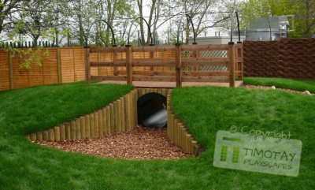

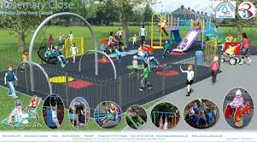

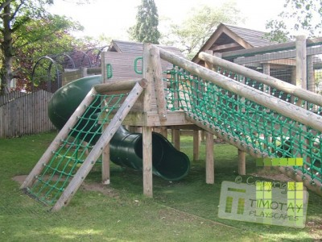

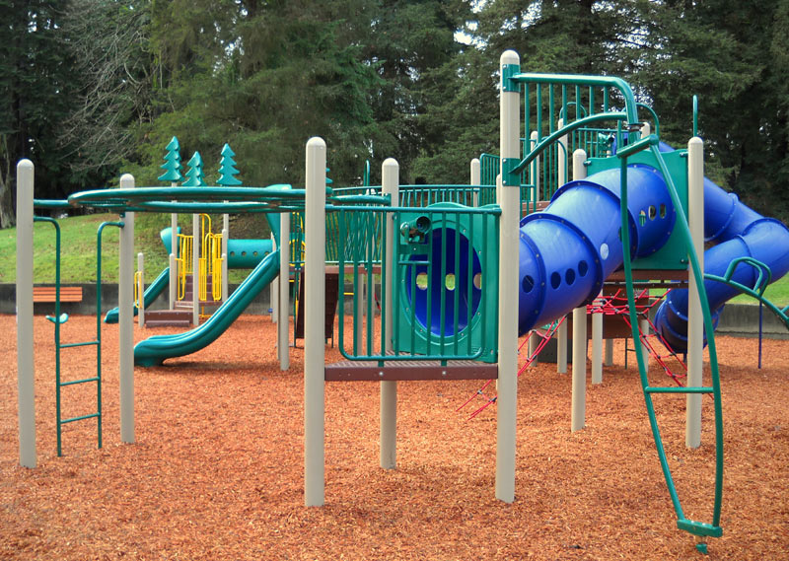

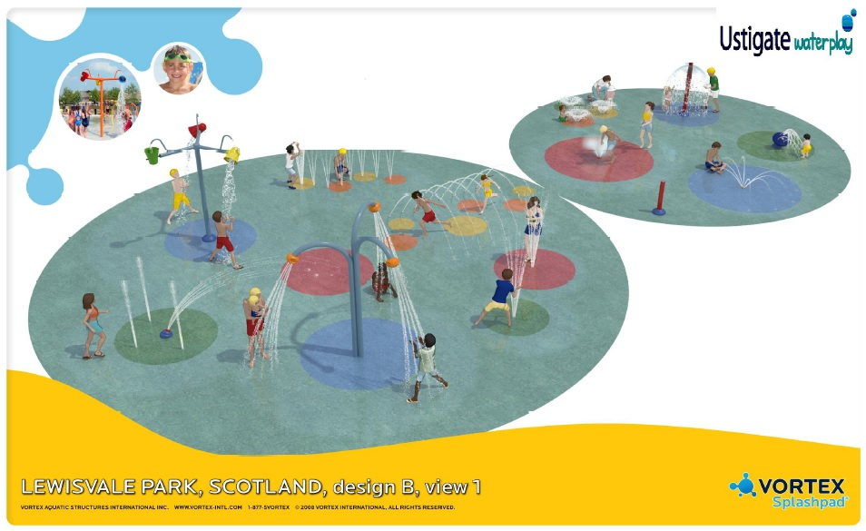

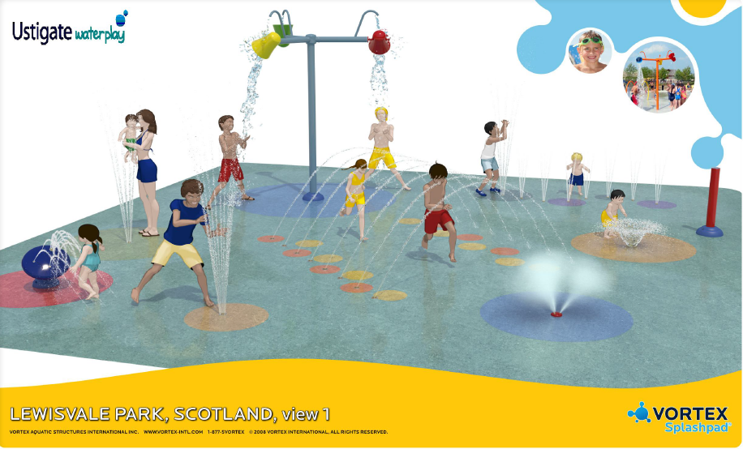

**Proposed projects...**

**To Replace the existing Play areas and Paddling Pool**

|  |  |  |
| --- | --- | --- |
| **No** | **Action** | **Vote** |
|  | Create a Water  ‘Fun park’ at Lewisvale Park. |  |
|  | Create a New  Play Area at Lewisvale Park |  |
|  | Create a Natural Playscape Park |  |
|  |  |  |
|  |  |  |

**LEWISVALE PARK REQUIRES A NEW UP TO DATE PLAY AREA FOR UNDER 5’s AND YOUTHS – WHAT TYPE OF PARK WOULD YOU LIKE TO SEE?**