East Lothian Council
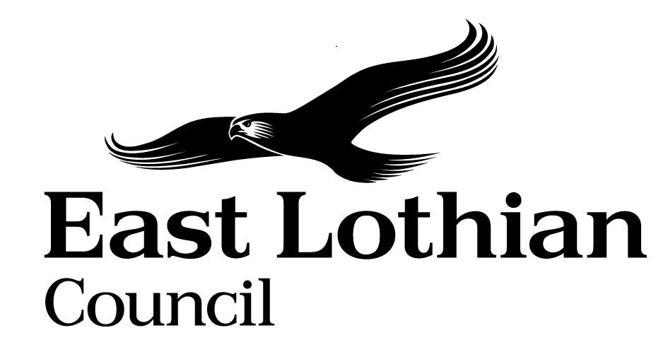
Report on Library Service Customer Survey

Introduction

A customer survey was undertaken earlier this year to find out what existing customers thought about the service and in particular to find out about their use of specific services – book borrowing, PC use and their interest in services such as e-books. This followed on from the Local Area Office and Library Satisfaction Survey carried out in September 2012, which surveyed the six town libraries alongside the Area Offices. This survey was carried out through a mix of exit interviews in larger libraries and completing questionnaires in smaller libraries, when customers had completed their visit to the library. There were 673 responses in total. The survey was carried out at 11 libraries, with a survey to be done at a later date in North Berwick, once the existing library re-opened in the refurbished premises. Overall the results of the survey showed a high degree of satisfaction with the service and in particular there were high levels of satisfaction with staff. The key findings are noted below.

Use of library services

50% of respondents use the library once or more than once a week and those that use the service do so very regularly. Borrowing and returning library books is the most popular reason for visiting the library at 64.1% followed by borrowing and returning DVDs at 22.5% and using a PC at 19.8%. In comparison to the survey in September 2012, book borrowing is still the highest transaction, overall, but PC use has increased. 12.7% of respondents borrow books with the family and 10.9% read newspapers and magazines.

What are the main reasons for your visit to the library today?
Answer Options | Response Percent | Response Count
Learning about an interest or hobby | 7.2% | 45
Studying | 5.0% | 31
Using a PC | 19.8% | 123
Borrowing or returning books | 64.1% | 399
Borrowing or returning DVDs | 22.5% | 140
Borrowing or returning music | 6.8% | 42
Borrowing or returning audio books | 5.6% | 35
Going to a reading-based event, like a reading group, Bookbug or author event | 4.0% | 25
Researching local/family history | 2.6% | 16
Going to a computer skills class | 1.9% | 12
Carrying out research | 4.7% | 29
Making an enquiry | 6.8% | 42
Borrowing books with the family | 12.7% | 79
Reading magazines/newspapers | 10.9% | 68
Using wi-fi | 5.1% | 32
Applying for a travel pass | 4.5% | 28
Other (please specify) |  | 91
answered question |  | 622
skipped question |  | 51

Books, followed by DVDs and then audio books were the most popular items borrowed.

Borrowers were asked whether they preferred borrowing paperbacks or hardbacks, but they showed no preference between the two formats. Respondents borrowed general fiction the most at 54.6%, followed by crime/thriller at 50.9%, then general non-fiction at 23.6% and biography at 21.9%. A high number mentioned historical fiction / history as a category.

529 of the 549, who commented, felt that it was easy or very easy to find books.

Customers were asked whether they had an e-reader and if so what type they had. 30.5% responded that they had an e-reader with 67% having a Kindle. 41.6 % said that they would use an e-book service.

The top four uses of the computers during a visit to the library were emailing family and friends 40.5%, using social media 30.7% printing 30.2% and looking for a job/CVs 20.6%.

If you used the computers/wi-fi today, what did you use it for? If you didn't use this service today please go to Q13.
Answer Options | Response Percent | Response Count
Studying for a course | 13.5% | 17
Looking for a job/CVs | 20.6% | 26
Using social media e.g. Face book, Twitter | 35.7% | 45
Booking a holiday | 9.5% | 12
Business | 7.1% | 9
Information on benefits | 4.8% | 6
E-mailing family and friends | 40.5% | 51
Printing | 30.2% | 38
Other (please specify) |  | 51
answered question |  | 126
skipped question |  | 547

98.8% were satisfied with the computers on their visit and 94.7% found the self service easy to use. 84.8% were satisfied that staff were knowledgeable in dealing with their enquiry, with 14.8% responding that they didn’t have an enquiry on their visit. 96.8% were satisfied that staff were helpful. There were 295 suggestions for improvements, which actually included 70 comments of praise for the service/staff. 60 comments were made regarding making improvements to opening hours. Some of these comments on opening hours related to Dunbar, whilst others related to the smaller libraries. There were 39 responses to the question on whether there were any barriers to accessing the service; with 15 people citing access to the building as an issue and 13 indicating that lack of toilets was a barrier, both of which relate to Musselburgh Library. An access audit at Musselburgh Library has also highlighted a number of access issues. Opening times and parking were also mentioned under barriers.

Our Customers

67% of customers were female with the highest age group 30% (195 people) being 65+, followed by those aged 35-44 at 17.3% and 45 -54 year olds at 15.7%. This survey produced a higher number of customers in different age groups compared to the survey undertaken in September 2012, with 110 in the 35-44 age group and 100 in the 45-54 age group. The over 65s are still the highest age group of users. Although it should be noted that children, who were not surveyed, are also high users of the service. 599 of respondents were white, 72.3% own their own home. 38.9% were retired with 17.9% working part time and 16.9% working full time.

Actions as a result of the survey
- Consider how to improve access and toilets for customers at Musselburgh Library
- Consider how to increase opening hours at Dunbar Library
- Continue to investigate e-book provision
- Conduct surveys regularly to seek the views of customers on service delivery and improvement

Alison Hunter
Principal Libraries Officer

